PALMER STATION MONTHLY SCIENCE REPORT

July 2006
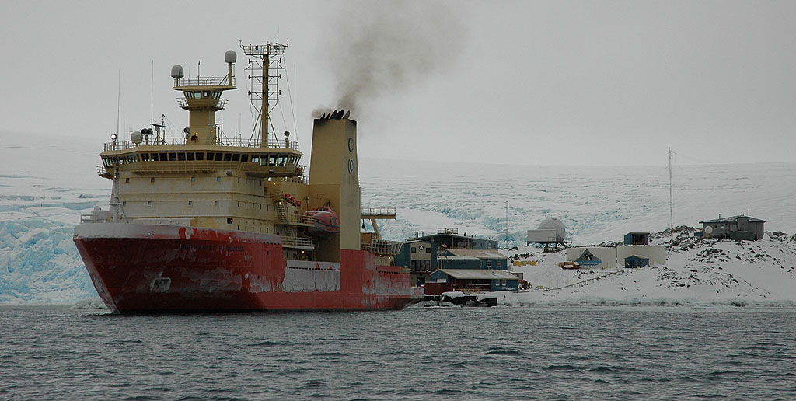
The R/V Nathaniel B. Palmer visits Palmer Station on July 29.
Photo Courtesy of Glenn Grant 2006

NEWS FROM THE LAB
Janice O’Reilly, Winter Assistant Supervisor, Laboratory Operations

Palmer Station was in full winter swing with short daylight hours and long work days. The winter-over staff focused on completing work orders, tracking cargo, and calling forward materials in preparation for the summer science season. There were no port calls until the end of the month.

On July 29 Palmer Station welcomed the arrival of the R/V Nathaniel B. Palmer with researchers from B-228-N (Mitchell). After approximately one month of conducting scientific research on the ship, grantees were happy to set foot on land. The day was busy with station tours, recreation, a cross-town dinner, and a science lecture. Several members of B-228-N (Mitchell) presented a lecture titled, “Plankton Community Structure and Iron Distribution in the Southern Drake Passage and Scotia Sea”. The interdisciplinary science team reported on how the Shackleton Transverse Ridge focuses a branch of the Antarctic Circumpolar Current (ACC) onto the peninsula shelf near Elephant Island and transports high iron shelf water into the open ocean, where it mixes and contributes to higher productivity in the Southern Scotia Sea. One surprise they reported was that chlorophyll concentrations in the open ACC waters are actually higher in winter than in summer and that the phytoplankton community seems healthier since iron is not limiting in winter as much as in summer.

Few animals were seen in the Palmer area during July. The elephant seal population had dwindled significantly on Elephant Rocks, and only five fur seals were seen in various locations: Humble Island, Bonaparte Point, Elephant Rocks, and the Backyard. One leopard seal was identified on July 2 and another on July 31, both in Arthur Harbor. Near the end of the month Weddell seals occasionally appeared next to Hero Inlet, one to three at a time, resting on the shore. There was one report of a gentoo penguin swimming near Humble Island and evidence indicating the recent presence of approximately one dozen penguins on Cormorant Island. Frequently seen in the station vicinity were giant petrels, blue-eyed shags, snowy sheathbills, kelp gulls, and Antarctic terns.

The Research Associate monitors the station’s geophysical projects and weather instrumentation. Following are summaries of the July weather and updates on projects currently taking place at Palmer Station.

JULY WEATHER

July’s weather was highly dynamic, starting the month with warm temperatures and frequent freezing rain, and ending considerably colder and calmer. The high temp for the month was +3.4C on the 4th, dipping to a low of -15.2C three weeks later. Average temperature was -4.3C, slightly warmer than the 15 year average of -4.9C. Melted precipitation was 32mm, much less than the normal monthly average of 53.9mm, but snowfall came in at 59cm, greater than the usual average of 49cm. The deepest depth at the snow stake was 49cm, still slightly below the average for July.

Sea ice concentrations were light throughout the month, with ice pancakes forming but then blowing out to sea, and the usual swaths of brash and bergy bits. Hero inlet continued to freeze up, but the fast ice is still mushy and gray. As the month drew to a close the pack ice had not yet arrived, but satellite images show it lurking just over the horizon to the west of us.

Wind gusts often peaked in the 50-knot range early on, but calmed as the month progressed. The peak recorded gust was 53 knots, and the average for the month was 12 knots. Prevailing winds were typically from the north or southwest, with the north winds bringing warmer temperatures and freezing rain, while the southwest winds brought cold, crisp temperatures and snow. At the end of the month a moderate high-pressure system was hovering over the Peninsula and showing no inclination to move, dropping temperatures and clearing the skies somewhat.

Palmer Station saw direct sunlight once again as the sun rose above the glacier on July 11th after an absence of 40 days. With the occasional clear skies came more morning and evening displays of beautiful, albeit ozone-destroying, nacreous clouds.

PALMER STATION
RESEARCH ASSOCIATE MONTHLY REPORT

July 2006

Organization of the Terralab continued throughout the month. As the lab has filled with furniture and equipment, it is becoming transformed from a barren, somewhat sterile lab space into a functional, vibrant work environment. Small homey touches – fake potted plants, a sound system, bits of colorful artwork – have added a pleasant feel to the building. During port calls by the R/V Laurence M. Gould and R/V Nathaniel B. Palmer the Research Associate provided tours of the facility and experiments to all interested visitors.

G-052-P GPS CONTINUOUSLY OPERATING REFERENCE STATION.
Jerry Mullins, Principal Investigator, U.S. Geological Survey

The Research Associate operates and maintains on-site equipment for the project. Throughout the month, 15-second epoch interval GPS data files were collected continually at station PALM, compressed, and transmitted to the NASA/CDDIS in Reston, VA.

The GPS reference station operated well throughout the month. Once during July the system was rebooted to install operating system patches, a normal part of operations.

G-090-P GLOBAL SEISMOGRAPH NETWORK (GSN) SITE AT PALMER STATION.
Rhett Butler, Principal Investigator, Incorporated Research Institutions for Seismology (IRIS)

The Research Associate operates and maintains on-site equipment for the project. Station PMSA is one of more than 130 sites in the GSN monitoring seismic waves produced by events worldwide. Data files are recorded to tape and also sent real-time to the U.S. Geological Survey (USGS).

The system performed flawlessly throughout the month. A seasonal vault visit was performed to re-center the seismometer masses, re-apply vacuum pressure to the bell jars that enclose the seismometers, and test the UPS batteries. Three tours of the vault and instrumentation were provided to interested station personnel during the visit.

O-202-P ANTARCTIC METEOROLOGICAL RESEARCH CENTER (AMRC) SATELLITE DATA INGESTOR.
Charles Stearns, Principal Investigator, University of Wisconsin

The Research Associate operates and maintains on-site equipment for the project. The AMRC SDI computer processes satellite telemetry received by the Palmer Station TeraScan system, extracting Automated Weather Station information and low-resolution infrared imagery and sending the results to AMRC headquarters in Madison, WI.

The system ran the entire month without intervention.

O-204-P A STUDY OF ATMOSPHERIC OXYGEN VARIABILITY IN RELATION TO ANNUAL TO DECADAL VARIATIONS IN TERRESTRIAL AND MARINE ECOSYSTEMS.
Ralph Keeling, Principal Investigator, Scripps Institution of Oceanography

Air samples are collected on a semiweekly basis by the Station Physician.

The goal of this project is to resolve seasonal and interannual variations in atmospheric O₂ (detected through changes in O₂/N₂ ratio), which can aid in determining rates of marine biological productivity and ocean mixing. The results are also used to help determine the terrestrial and oceanic distribution of the global anthropogenic CO₂ sink. The program involves air sampling at a network of sites in both the Northern and Southern Hemispheres. Palmer Station is especially well situated for resolving signals of carbon cycling in the Southern Ocean. Samples taken from the station are sent to Scripps where the analysis of O₂ and CO₂ content takes place.

O-264-P COLLECTION OF ATMOSPHERIC AIR FOR THE NOAA\CMDL WORLDWIDE FLASK SAMPLING NETWORK.
David Hofmann, Principal Investigator, Climate Monitoring and Diagnostics Laboratory, National Oceanic and Atmospheric Administration

The National Oceanic and Atmospheric Administration (NOAA) Climate Monitoring and Diagnostics Laboratory continues its long-term measurements of carbon dioxide and other climate relevant atmospheric gases. The Palmer Station air samples are returned to the NOAA laboratory for analysis as part of NOAA's effort to determine and assess the long-term buildup of global pollutants in the atmosphere. Data from this experiment will be used in modeling studies to determine how the rate of change of these parameters affects climate. Air samples are collected on a weekly basis by the Station Physician.

A-306-P GLOBAL THUNDERSTORM ACTIVITY AND ITS EFFECTS ON THE RADIATION BELTS AND THE LOWER IONOSPHERE.
Umran Inan, Principal Investigator, Stanford University

Stanford University has been operating a Very Low Frequency (VLF) receiver antenna at Palmer Station since the 1970's. By receiving naturally and manmade signals between 1 and 40 kHz, the Stanford VLF group is able to study a wide variety of electromagnetic phenomenon in the ionosphere (uppermost layer of the atmosphere ionized by solar radiation) and magnetosphere (the area surrounding the earth dominated by the Earth's magnetic field and particles trapped by it. Many of these studies relate to the energetic releases associated with lightning. For example, Palmer Station's unique location enables it to pick up small bits of radiation from lightning strikes as far away as Africa, the USA, or the Pacific Ocean.

The antenna cable that runs up the glacier required frequent maintenance during July. Following a severe storm, the cable came detached from many of the 4x4 support posts and drifted a short distance along the glacier. The cable was carefully extracted from the snow and ice, and reattached to the posts and supporting messenger wire. Since the zip-ties (used to attach the cable to the posts and wire) are the part that is failing, a new attachment system was initiated and appears to be working better. At every post, a short loop of rope is tied around the cable in a cinching prusik knot, and the other end of the loop is hooked on the post. As wind stress increases on the cable, the knot grabs tighter. The ropes are still subject to normal wear-and-tear, but the so far they’re working considerably better than the flimsy zip-ties. Additionally, several special recordings for studying Terrestrial Gamma-ray Flash (TGF) events were made.

T-312-P TERASCAN SATELLITE IMAGING SYSTEM.
Dan Lubin, Principal Investigator, Scripps Institution of Oceanography

The Research Associate operates and maintains on-site equipment for the project. Throughout the month, the TeraScan system collected, archived, and processed DMSP, NOAA, and ORBVIEW-2 satellite telemetry, capturing approximately 25-30 passes per day. A weekly 85GHz SSM/I ice concentration image was produced and transferred to UCSB for B-032-P (Smith).

The system performed well during July. The antenna dome heater failed twice due to a tripped GFI outlet; a work-around for powering the heater has been implemented until a permanent fix can be installed. Images with bright auroras were observed frequently during the month.

A-357-P EXTENDING THE SOUTH AMERICAN MERIDIONAL B-FIELD ARRAY (SAMBA) TO AURORAL LATITUDES IN ANTARCTICA
Eftyhia Zesta, Principal Investigator, University of California Los Angeles

The three-axis fluxgate magnetometer is one in a chain of longitudinal, ground-based magnetometers extending down though South America and into Antarctica. The primary scientific goals are the study of ULF (Ultra Low Frequency) waves and the remote sensing of mass density in the inner magnetosphere during geomagnetically active periods. Palmer’s magnetometer is also a conjugate to the Canadian Poste de la Baleine station, allowing the study of conjugate differences in geomagnetic substorms and general auroral activity. The station Research Associate maintains the on-site system.

The system performed well, requiring intervention only for operating system patches and upgrades.

B-390-P: THERMO-SALINOGRAPH
Vernon Asper, Principal Investigator, University of Southern Mississippi

Sea water is pumped continuously through a thermosalinograph (TSG) sampling system, recording the temperature, conductivity, salinity, and fluorescence. The real-time data, including graphs and web camera images of the ocean in the vicinity of Palmer Station, are compiled by a local server into web page format and relayed to a mirror site at Woods Hole Oceanographic Institute, which is a collaborator in the project. The URL for the WHOI mirror site is http://4dgeo.whoi.edu/tsg/.

The system operated throughout the month without incident.

T-513-P ULTRAVIOLET SPECTRORADIOMETER NETWORK
Charles Booth, Principal Investigator, Biospherical Instruments, Inc

The Research Associate operates and maintains on-site equipment for the project. A BSI SUV-100 UV spectroradiometer produces full sky irradiance spectra ranging from the atmospheric UV cutoff near 290nm up to 605nm, four times per hour, while the sun is above the horizon. A BSI GUV-511 filter radiometer, which has four channels in the UV and one channel in the visible for measuring Photosynthetically Active Radiation (PAR), is located next to the SUV-100. Data from the GUV-511 instrument is made available on a daily basis on the project’s website at http://www.biospherical.com/nsf.

The UV monitor performed normally in July. Several absolute scans were performed as a part of normal operations. Data collection during the month was greatly reduced due to short daylight hours.

T-998-P: IMS RADIONUCLIDE MONITORING
Michael Pickering, Principal Investigator, General Dynamics

The International Monitoring System (IMS) radionuclide sampler is part of the Comprehensive Test Ban Treaty (CTBT) verification regime. The automated Radionuclide Aerosol Sampler and Analyzer (RASA) unit pumps air continuously through a filter for 24 hour periods, collecting particulates in the .2-10 micron range. The filter is then tested for particulates with radioisotope signatures indicative of a nuclear weapons test. The station Research Associate operates and maintains the instrument.

The RASA system required debugging and rebooting once during the month, due to apparent network problems. Filter samples were prepared for shipment in accordance with CTBTO guidelines.

TIDE GAGE

The Research Associate operates and maintains on-site equipment for the project. Tide height, seawater temperature, and salinity are monitored on a continual basis by a gage mounted at the Palmer Station pier.

The tide gage ran the entire month without incident.

METEOROLOGY

The Research Associate acts as chief weather observer, and compiles and distributes meteorological data. At the end of the month a summary report is prepared and sent to interested parties. Weather data collected using the automated electronic system is archived locally and forwarded twice each month to the University of Wisconsin for archiving and further distribution. Synoptic reports are automatically generated every six hours by the Palmer Meteorological Observing System (PalMOS) and emailed to the NOAA for entry into the Global Telecommunications System (GTS).

Weather data continued to be provided to the R/V Nathanial B. Palmer in support of the ongoing science cruise. The system is performing well, with minimal operator intervention. Late in the month an automated script was installed to FTP PalMOS observations to SPAWAR on a 15-minute basis in support of weather forecasting.

