PALMER STATION MONTHLY SCIENCE REPORT

March 2006
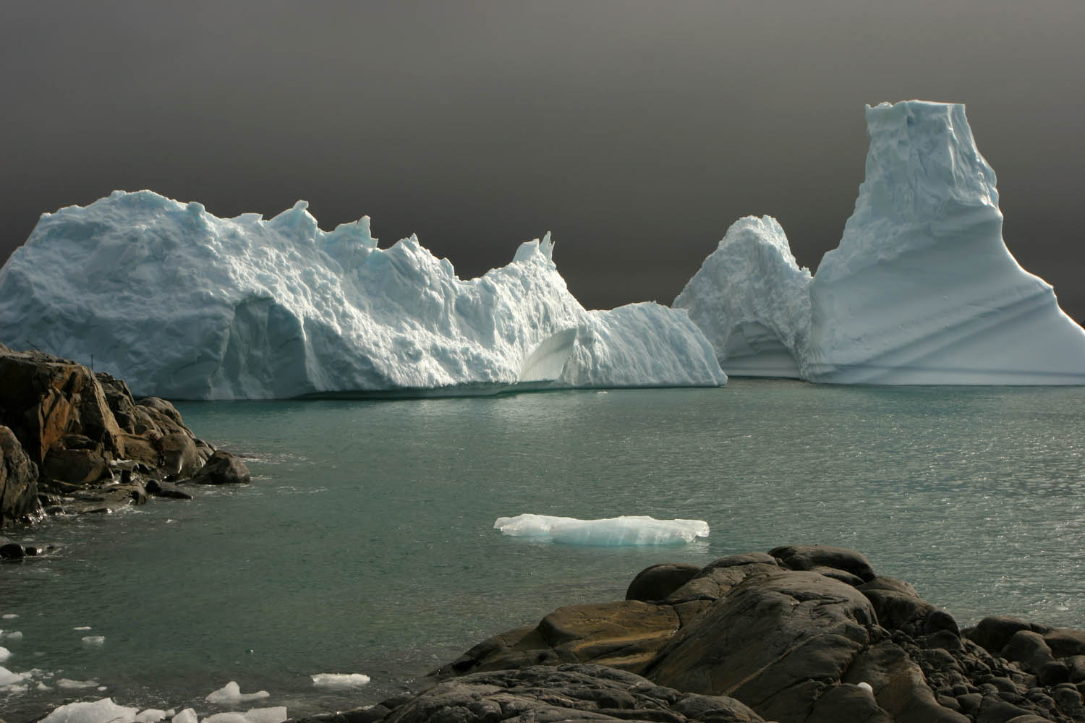
Sunlight Iceberg Gathering, near Palmer Station

NEWS FROM THE LAB
Tracey Baldwin, Senior Assistant Supervisor, Laboratory Operations

March was the month of winter preparations. Station saw two visits from the ARSV Laurence M. Gould (LMG) and the arrival of the majority of the winter over support staff on the final days of the month. The weather continued to prove difficult for final science sampling days. Station science population dwindled as all but two groups left station this month. RPSC support staff continued to assist in science sampling as needed with general assistance and continued monitoring of the Giant Petrel Chicks on Humble Island. Station tourist season came to a close in February and no cruise ships or yachts visited station this month.

Station population was considerably lower for the majority of the month with 33 persons on site: 11 scientists representing 5 projects and 22 support staff. The beginning of the month had a full 44 persons on station until several members of the science community departed on LMG 06-02 NB. The month ended with the departure of more science and the arrival of a large portion of the winterover support staff, including Brett Pickering, Winter Site Manager.

Data continues to be collected on 12 projects as well as meteorological and tidal through the assistance of Dr. Steve Dobbs, Research Associate, and air sampling by Dr. Greg Zaar, Station Physician. Barb Watson, Instrument Technician, began post-season monitoring for B-013-P (Fraser) of the Giant Petrel chicks on Humble Island.

High winds were the primary cause of sampling delays this month. A 60 knot peak wind was observed on 8 March with a monthly average speed of 12 knots. Brash ice from the very active glacier in our backyard continued to slow boating in and around station. The average temperature has dropped to 2.7° C and precipitation increased to 97.8 mm melted and 5 cm of snow, confirming that winter is upon us. Additional weather data can be found in the Meteorological section below.

The following projects conducted research at Palmer Station during March:

B-003-P: RESPONSE OF TERRESTRIAL ECOSYSTEMS ALONG THE ANTARCTIC PENINSULA TO A CHANGING CLIMATE
Thomas A. Day, Principal Investigator, Arizona State University, Tempe, AZ.
Personnel on station: Sarah Strauss, Matt Krna, Caroline DeVan

This month we made the final field measurements in our climate manipulation plots behind Palmer Station. Each plot contained microcosms consisting of intact terrestrial plants and native soil. We supplemented temperature (with IR heaters) and precipitation (addition) to these microcosms, simulating predicted climate change for the Antarctic Peninsula. The overall goal of this experiment is to determine how future climate change will affect tundra productivity and nutrient cycling. Microclimate measurements under our plots were continuously monitored along with precipitation collection. We made our final weekly measurements of CO₂ flux from the microcosms this month providing us estimates of net microcosm CO₂ exchange and respiration. In conjunction with these measurements we also made our final measurements of evapotranspiration and soil leachates from the microcosms. We also concluded our measurements of vegetative and reproductive growth of both species of vascular plants (Deschampsia antarctica and Colobanthus quitensis). In conjunction with final measurements, frames and heaters comprising each plot were removed from the field site with the assistance of Raytheon personnel.

Once measurements were completed, we harvested microcosms or cores from the experiment. Harvests will allow us to determine the above- and belowground mass of each plant species and litter in each core, as well as allocation to reproductive structures. These samples will be returned to our home institution for analysis of nutrient concentrations and stable isotope ratios to allow us to assess carbon and nitrogen stocks. Prior to harvests, we also extracted microarthropods (midge larvae, mites and springtails) from cores. Additional samples were collected to allow us to assess the abundance and diversity of soil microbes in cores.

We continued to monitor plant colonization, growth, soil/microbial respiration and soil invertebrate abundance in recently deglaciated sites in the Arthur Harbor area which are being compared to a long-established tundra site (Stepping Stones Island). We also censused plant populations at several recently deglaciated sites in the Arthur Harbor area that we have been monitoring since 1998. On March 11 we visited Biscoe Point and sampled plots that we established for vegetation monitoring in 2003. Additional field work involved removing plot markers and stakes from our field sites in the Palmer area.

We thank personnel at Palmer Station for their continued support during the month. Special thanks to Steve Barton for boating support, Curt Smith and Sarah Kaye for assistance in resolving computer issues, Ryan Wallace, Paul Smotherman, Curt Smith, Kerry Kells and Dave Ensworth for field assistance, Heidi Schernthanner and Rebecca Shoop for logistical support, and Barb Watson and Tracey Baldwin for lab assistance.

B-016-P and B-032-P Long Term Ecological Research on the Antarctic Peninsula, an Ice Dominated Ecosystem - Phytoplankton Ecology and Bio-Optical Components
Principle Investigators: Dr. Maria Vernet, Scripps Institution of Oceanography (B-016-P)
Dr. Raymond Smith, University of California, Santa Barbara (B-032-P)

Personnel on station: Jennie Husby (032), Julie Schram (032), Karie Sines (016), and Tristan Wohlford (016) (Scripps Institution of Oceanography)

Palmer stations E and B were each sampled 8 times during the month of March. Samples were collected from both stations on 03, 06, 09, 13, 18, 23, 28, and 31 March. Sampling was done twice a week except for the week of 19-25 March when high wind conditions made it impossible to go out more than once. In addition to the core sampling for the LTER data set, five DOC experiments were conducted on water collected from station B on 01, 07, 14, 24, and30 March.

Production levels were relatively low for the entire month of March, peaking during the middle of the month and then steadily declining with the lowest values at the end of the month. Notably, there was a sharp drop in production following the week of high winds (19-25 March). Integrated production for the month for stations E and B, respectively, ranged from highs of 418mgC m⁻² d⁻¹ and 493mgC m⁻² d⁻¹ on 13 March to lows of 74mgC m⁻² d⁻¹ and 63.55mgC m⁻² d⁻¹ on 31 March. Chlorophyll levels at station E mirrored the trends seen in production with a high of 54.0ug m⁻² on 13 March and a low of 12.3ug m⁻² on 31 March. Chlorophyll levels at station B peaked on the sampling day prior to the peak seen in production with 65.2ug m⁻² on 9 March. The lowest chlorophyll level at station B was seen on the same day as the lowest production level (31 March) with 11.1ug m⁻².

B-045-P Palmer, Antarctica Long-Term Ecological Research Project: Long-Term Ecological Research on the Antarctic Marine Ecosystem: Climate Migration, Ecosystem Response and Teleconnections in an Ice-Dominated Environment: Microbial Ecology and Biogeochemistry Component
Hugh Ducklow, Principal Investigator, School of Marine Science, The College of William and Mary
Personnel on station: Nicole Middaugh and Matthew Erickson

March proved to be a swell month for data collection. Our principle investigator departed in mid March entrusting the last of the season’s sampling to Matthew and I. We only missed one sampling day due to weather, and what turned out to be a fantastic 5 day storm. Our bacterial production assays show a decline bacterial activity over the course of the month, consistent with the trends of previous years. Our large volume water collection continued once a week every Friday and also showed a decline in bacteria and other matter in the water column over the course of the month.

This month we continued our new experiment of extremely large volume filtration from station B. We collected and performed three filtrations in the second half of the season, once in February and twice this month. We collected 600 L of water at 5 m in the water column and filtered it down to approximately 600 mL of water concentrated with bacteria. We then passed the 600 mL into approximately 10 Sterivex filters for bacterial species identification and creation of a DNA library.

The end of the season is upon us, and B-045 would like to thank all Raytheon employees and other NSF scientists for a wonderful and successful season.

PALMER STATION RESEARCH ASSOCIATE MONTHLY REPORT

G-052-P GPS CONTINUOUSLY OPERATING REFERENCE STATION.
Jerry Mullins, Principal Investigator, U.S. Geological Survey

The Research Associate operates and maintains on-site equipment for the project. Throughout the month, 15-second epoch interval GPS data files were collected continually at station PALM, compressed, and transmitted to the NASA/CDDIS in Reston, VA.

The heliax receiving antenna cable was removed from under the VLF Hut, which is scheduled for demolition, and rerouted in a more direct route to the new equipment location in Terra Lab. The new routing allowed the cable to be shortened by about 30 meters.

G-090-P GLOBAL SEISMOGRAPH NETWORK (GSN) SITE AT PALMER STATION.
Rhett Butler, Principal Investigator, Incorporated Research Institutions for Seismology (IRIS)

The Research Associate operates and maintains on-site equipment for the project. Station PMSA is one of more than 130 sites in the GSN monitoring seismic waves produced by events worldwide. Data files are recorded to tape and also sent real-time to the U.S. Geological Survey (USGS).

The six-month maintenance tasks were performed. Additional vacuum was pulled on two of the three seismic axes. All three axes were zeroed. The batteries were checked.

At the end of the month this system was transitioned to Terra Lab. This transition required rerouting the fiber optic data cable, and modifying the seismometer electronics, the Data Acquisition (DA) equipment, and the Data Processing (DP) equipment. A door switch was installed on the seismic vault door so the status of the door can be monitored remotely. New software was also loaded on both the DA and DP equipment. These modifications were required so that this equipment can be interfaced with the new Comprehensive Test Ban Treaty Organization (CTBTO) seismic equipment.

O-202-P ANTARCTIC METEOROLOGICAL RESEARCH CENTER (AMRC) SATELLITE DATA INGESTOR.
Charles Stearns, Principal Investigator, University of Wisconsin

The Research Associate operates and maintains on-site equipment for the project. The AMRC SDI computer processes satellite telemetry received by the Palmer Station TeraScan system, extracting Automated Weather Station information and low-resolution infrared imagery and sending the results to AMRC headquarters in Madison, WI.

The system ran the entire month without incident.

O-204-P A STUDY OF ATMOSPHERIC OXYGEN VARIABILITY IN RELATION TO ANNUAL TO DECADAL VARIATIONS IN TERRESTRIAL AND MARINE ECOSYSTEMS.
Ralph Keeling, Principal Investigator, Scripps Institution of Oceanography

Air samples are collected on a semiweekly basis by the station physician.

The goal of this project is to resolve seasonal and interannual variations in atmospheric O2 (detected through changes in O2/N2 ratio), which can aid in determining rates of marine biological productivity and ocean mixing. The results are also used to help determine the terrestrial and oceanic distribution of the global anthropogenic CO2 sink. The program involves air sampling at a network of sites in both the Northern and Southern Hemispheres. Palmer Station is especially well situated for resolving signals of carbon cycling in the Southern Ocean. Samples taken from the station are sent to Scripps where the analysis of O2 and CO2 content takes place.

Discussions concerning how and when to move this experiment to TerraLab are continuing.

O-264-P COLLECTION OF ATMOSPHERIC AIR FOR THE NOAA\CMDL WORLDWIDE FLASK SAMPLING NETWORK.
David Hofmann, Principal Investigator, Climate Monitoring and Diagnostics Laboratory, National Oceanic and Atmospheric Administration

The National Oceanic and Atmospheric Administration (NOAA) Climate Monitoring and Diagnostics Laboratory continues its long-term measurements of carbon dioxide and other climate relevant atmospheric gases. The Palmer Station air samples are returned to the NOAA laboratory for analysis as part of NOAA's effort to determine and assess the long-term buildup of global pollutants in the atmosphere. Data from this experiment will be used in modeling studies to determine how the rate of change of these parameters affects climate. Air samples are collected on a weekly basis by the station physician.

O-283-P ANTARCTIC AUTOMATIC WEATHER STATIONS (AWS).
Charles Stearns, Principal Investigator, University of Wisconsin

The Research Associate monitors data transmissions for the project. AWS transmissions from Bonaparte Point, Hugo Island, and Racer Rock were monitored using the TeraScan system, with only Bonaparte Point currently operational. AWS data received was also forwarded to UCSB for B 032 P (Smith).

A-306-P GLOBAL THUNDERSTORM ACTIVITY AND ITS EFFECTS ON THE RADIATION BELTS AND THE LOWER IONOSPHERE.
Umran Inan, Principal Investigator, Stanford University

The Research Associate operates and maintains on-site equipment for the project. The Stanford equipment receives and records Very Low Frequency (VLF) radio waves in order to study natural ionospheric and magnetospheric phenomena, as well as to study the distribution of the lightning strikes that are a principle source of natural VLF signals. Broadband synoptic data was recorded on a schedule of three out of every 15 minutes each day, and broadband continuous data was recorded for at least nine hours per day. Narrowband continuous data was collected for 12 hours each day.

Additional data recordings were collected this month in support Terrestrial Gamma-ray Flash (TGF) events.

VLF_NB data was collected constantly, 24 hours a day, for ten days. This data is to be used as proof/verification that daily patterns can be seen in the data. During this special collection effort, data DVDs could not be burned on the narrowband computer. These DVDs were burned over a three day period after the special data collection terminated.

T-312-P TERASCAN SATELLITE IMAGING SYSTEM.
Dan Lubin, Principal Investigator, Scripps Institution of Oceanography

The Research Associate operates and maintains on-site equipment for the project. Throughout the month, the TeraScan system collected, archived, and processed DMSP, NOAA, and ORBVIEW-2 satellite telemetry, capturing approximately 25-30 passes per day. A weekly 85GHz SSM/I ice concentration image was produced and transferred to UCSB for B 032 P (Smith).

TeraScan images were provided on an as available basis in support of the upcoming NBP06-03 cruise.

The TeraScan system was successfully transitioned to Terra Lab. This transition required pulling the signal and data cables out of existing conduit. Installing new conduit, and installing the cables in the new conduit. Rerouting the cables was hampered by a splice in the cable which created a stiff section that would not feed through the conduit runs properly. Since the cable could not be entirely extracted from the old conduit, it was necessary to interface the old conduit run to the new conduit run and modify the new conduit run to accommodate the stiff section. The electronics equipment rack and computer were moved without significant problems.

A-357-P EXTENDING THE SOUTH AMERICAN MERIDIONAL B-FIELD ARRAY (SAMBA) TO AURORAL LATITUDES IN ANTARCTICA
Eftyhia Zesta, Principal Investigator, University of California Los Angeles

The three-axis fluxgate magnetometer is one in a chain of longitudinal, ground-based magnetometers extending down though South America and into Antarctica. The primary scientific goals are the study of ULF (Ultra Low Frequency) waves and the remote sensing of mass density in the inner magnetosphere during geomagnetically active periods. Palmer’s magnetometer is also a conjugate to the Canadian Poste de la Baleine station, allowing the study of conjugate differences in geomagnetic substorms and general auroral activity. The station Research Associate maintains the on-site system.

A new sensor and interface electronics were received this month. Both were installed and are currently operating. The old sensor and its interface electronics have been packed and are ready to be returned to the grantee.

B-390-P: THERMO-SALINOGRAPH
Vernon Asper, Principal Investigator, University of Southern Mississippi

Sea water is pumped continuously through a TSG sampling system, recording the temperature, conductivity, salinity, and fluorescence. The real-time data, including graphs and web camera images of the ocean in the vicinity of Palmer Station, are compiled by a local server into web page format and relayed to a mirror site at Woods Hole Oceanographic Institute, which is a collaborator in the project. The URL for the WHOI mirror site is http://4dgeo.whoi.edu/tsg/.

The system ran the entire month without problems.

T-513-P ULTRAVIOLET SPECTRORADIOMETER NETWORK
Charles Booth, Principal Investigator, Biospherical Instruments, Inc

The Research Associate operates and maintains on-site equipment for the project. A BSI SUV 100 UV spectroradiometer produces full sky irradiance spectra ranging from the atmospheric UV cutoff near 290nm up to 605nm, four times per hour, while the sun is above the horizon. A BSI GUV-511 filter radiometer, which has four channels in the UV and one channel in the visible for measuring Photosynthetically Active Radiation (PAR), is located next to the SUV 100. Data from the GUV-511 instrument is made available on a daily basis on the project’s website at http://www.biospherical.com/nsf.

One single lamp absolute calibration and one three lamp sequence absolute calibration were completed. The system was essentially problem free during the month. Discussions continued on how this experiment will be transitioned to Terra Lab.

T-988-P: IMS RADIONUCLIDE MONITORING
Erik Swanberg, Principal Investigator, General Dynamics

The International Monitoring System (IMS) radionuclide sampler is part of the Comprehensive Test Ban Treaty (CTBT) verification regime. The automated Radionuclide Aerosol Sampler and Analyzer (RASA) unit pumps air continuously through a filter for 24 hour periods, collecting particulates in the .2-10 micron range. The filter is then tested for particulates with radioisotope signatures indicative of a nuclear weapons test. The station Research Associate operates and maintains the instrument.

RASA exhibited a minor problem during the month. A software patch was provided by the grantee and installed by the Research Associate.

TIDE GAGE
The Research Associate operates and maintains on-site equipment for the project. Tide height, seawater temperature, and salinity are monitored on a continual basis by a gage mounted at the Palmer Station pier.

The tide gage ran the entire month without problems.

METEOROLOGY
The Research Associate acts as chief weather observer, and compiles and distributes meteorological data. At the end of the month a summary report is prepared and sent to interested parties. Weather data collected using the automated electronic system is archived locally and forwarded twice each month to the University of Wisconsin for archiving and further distribution. Synoptic reports are automatically generated every six hours by the Palmer Meteorological Observing System (PalMOS) and emailed to the NOAA for entry into the Global Telecommunications System (GTS). Current weather observations for all Antarctic stations, including Palmer, are available on the web at: http://www.wunderground.com/global/AA.html.

Both PalMOS and MAWS ceased operation on the same day. The problem in each case was traced to failed RS485 communications circuits. PalMOS was repaired the day it failed. MAWS was repaired three days later. Both systems have operated properly since the repairs were made. An effort was made to identify something that might have caused the closely timed failures but nothing was found.

Spare parts were ordered and are being sent via the silver trunk.

