CTD Operations
Nathaniel B. Palmer

CTD Operations

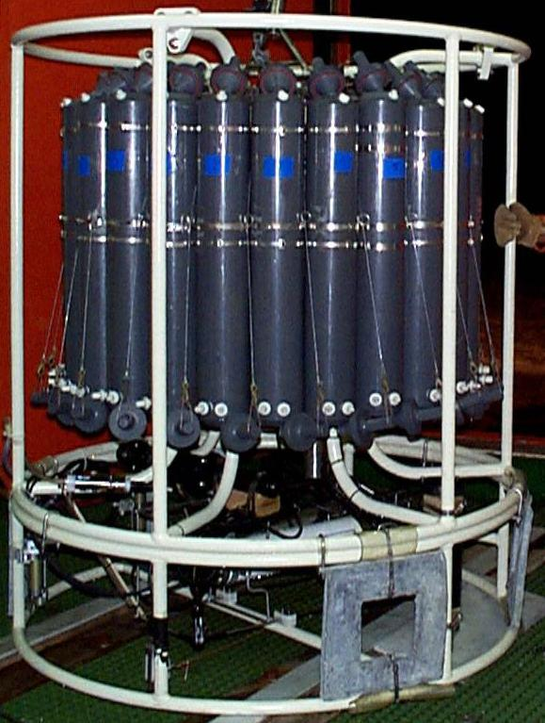

Nathaniel B. Palmer

Software Operations
Setup of the CTD Package
Baltic Room Procedures
Running Salts
Preliminary Data Processing

CTD Operations

Nathaniel B. Palmer

Software Operations
Setup of the CTD Package
Baltic Room Procedures
Running Salts
Preliminary Data Processing

