II. Deploying the CTD Package

One of the most important aspects of a CTD cast is keeping constant communication between the Bridge, the Dry Lab, and the Baltic Room. When communicating with the Bridge and the team in the Baltic Room from the Dry Lab, use the radio on channel 06. When communicating with the winch operator, use the intercom located to the left of the CTD terminal. Depress the button on the handset to talk.

Pre-Cast
Baltic Room
(1/2 hour before station)
- Cock the bottles (see Appendix I for bottle components):
NOTE: Some of the bottles may not be completely empty, so when you cock the bottom stop, water may come out.
- Unclip lanyards from bottom bottle stops.
- Close the triggers on the pylon in the top center of the rosette—push down until it clicks.
- Start with bottle 1. Open top stop so that the loop of the lanyard can fit over trigger numbered 1.
- Work around the rosette, cocking all the bottles on top.
- Open bottom stops, making sure to keep the lanyard clear of the spigots, and clip open to the bottom of the lanyard.
- Make sure the top bleed valves (white screws) are closed.
- Close all spigots on all bottles by pulling them out. The dials on the spigot should spin.
- Make a visual inspection of the CTD package, checking the following:
- All O-rings look well-seated on the bottles (top and bottom).
- All bleed valves and spigots are closed.
- Winch cable won’t catch on anything when the CTD package is deployed.
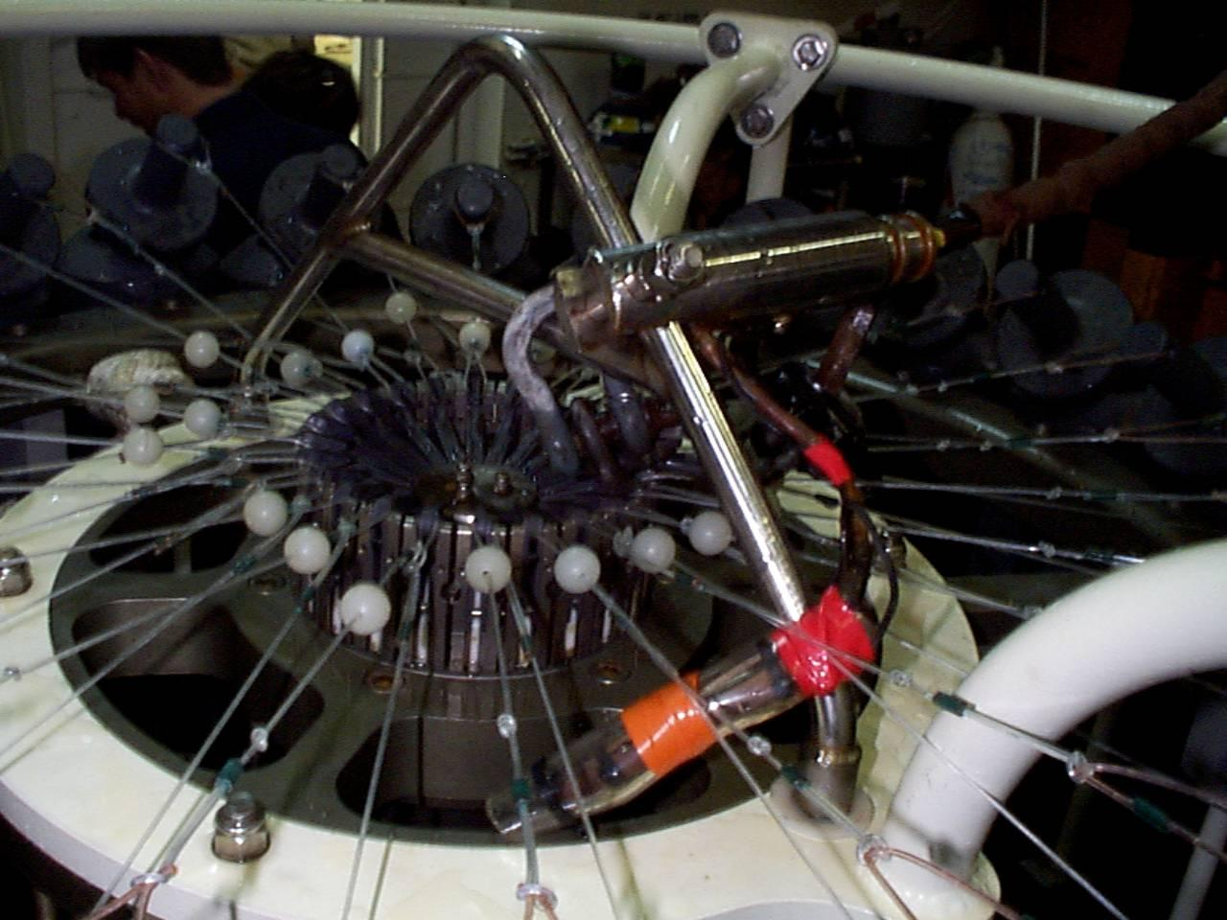
cocked rosette
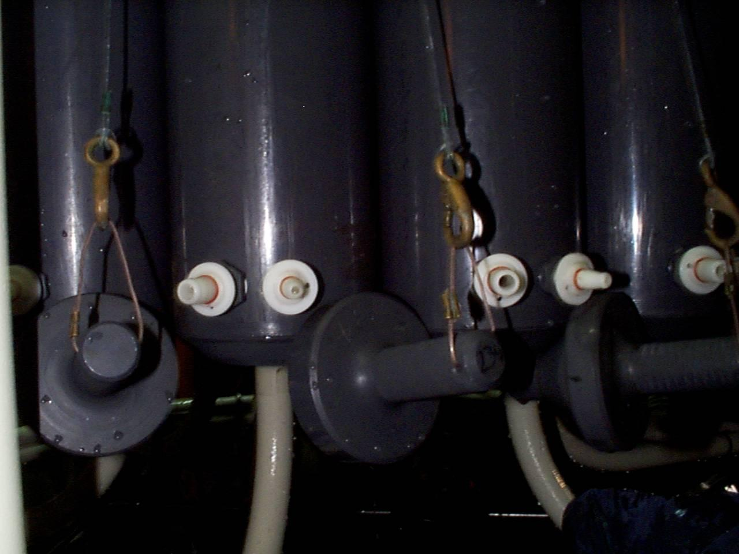
spigots on cocked bottle

Dry Lab

- Record the event or station number for this cast. On some cruises, it may be necessary to call the Bridge to get an event number.
- On the SeaBird computer, at the C:\SEASOFT4.234> prompt, type
seasave
and press <Enter>.
- From the Main Menu, select “Acquire and Display Real-Time Data” and press <Enter>.
- Preliminary Screen:
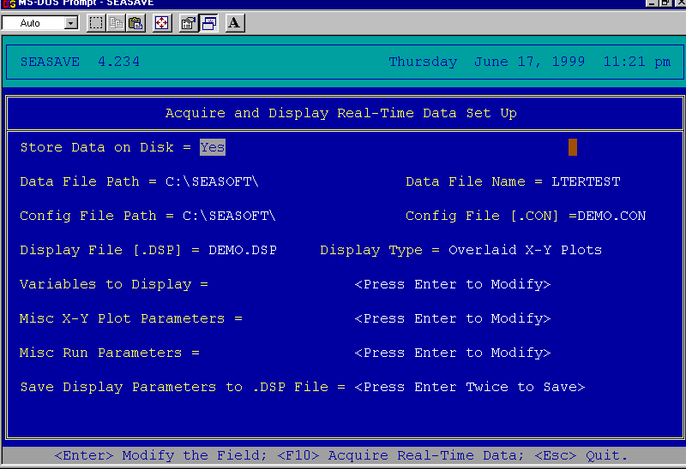

- FILE NAME: Change file name (e.g., LTERTEST.DAT) for this particular cast.
- DISPLAY FILE: Change the display file for the cast type (usually for the depth range). Please see Appendix A for a list of display files.
- VARIABLES TO DISPLAY: Adjust the variables you want to display by choosing temperature, conductivity, etc.—whatever you want to see plotted during the actual cast.
- MISC X-Y PLOT PARAMETERS: These are the scan line variables. The scan line is displayed at the bottom of the screen during a cast, and can display data in numbered form. Press X—your choice, for instance, the altimeter (if it’s on the package), or BCT (Bottom Contact).
- If you change any of the settings in VARIABLES TO DISPLAY, MISC X-Y PLOT PARAMETERS, or MISC RUN PARAMETERS, you may wish to save theses settings in a new display file. To do this, select Save Display Parameters to .DSP File at the bottom of the screen. Then press <Enter> twice, and name your customized display file.
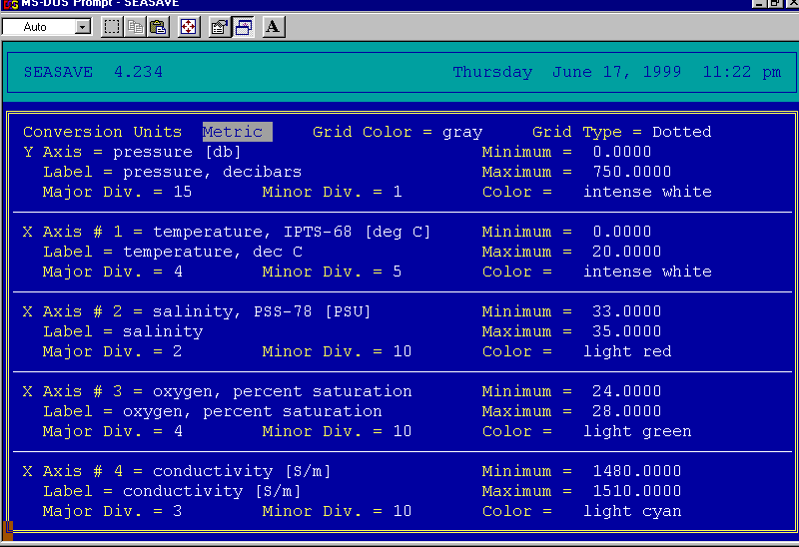
Variables to Display Screen

Cast Procedure
Operating in Ice
Casting a CTD package in sea ice fields is very different from casting in open ocean. The instruments located on the bottom of the package are very sensitive, and can break easily, or become fouled, if frozen or hit by ice.
- If casting in a hole dug through pack ice, keep the hole clear of brash ice or slush as the package is going into and coming back up through the surface.
- The mate on watch will use the ship to create an opening in the ice and maintain the area free of ice.

Baltic Room
There will be 3 people in the Baltic Room to perform a cast, typically comprised of one ASA employee (usually an MT), one scientist, and the winch operator (provided by ECO). Once these three people are inside, secure the Baltic Room by dogging all the interior doors. This must be done in order to open the Baltic Room door to deploy the CTD package.

NOTE: The CTD package should NEVER be put in the water with bottles closed and full of air. This will crush the bottles.
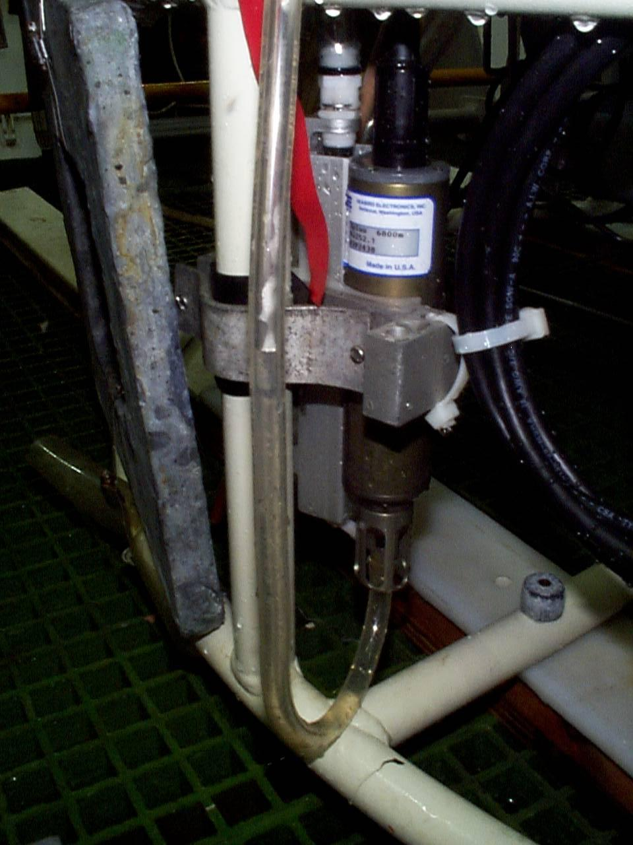
distilled water tube on temperature sensor
- Disconnect the distilled water tubes (marked with red ribbons) from the two temperature sensors by pulling them off.
- Turn on the pinger (bottom sensor) by pulling out the magnet marked with a red ribbon. It will start to ping.
- Unsecure the CTD package.
- The Bridge will give the word when it is safe to open the Baltic Room Door.
- The winch will move the CTD package toward the door.
- Throw the bottom contact line out before the CTD package goes out.
- The boom will move out first. Then the winch will lower the CTD in the water.
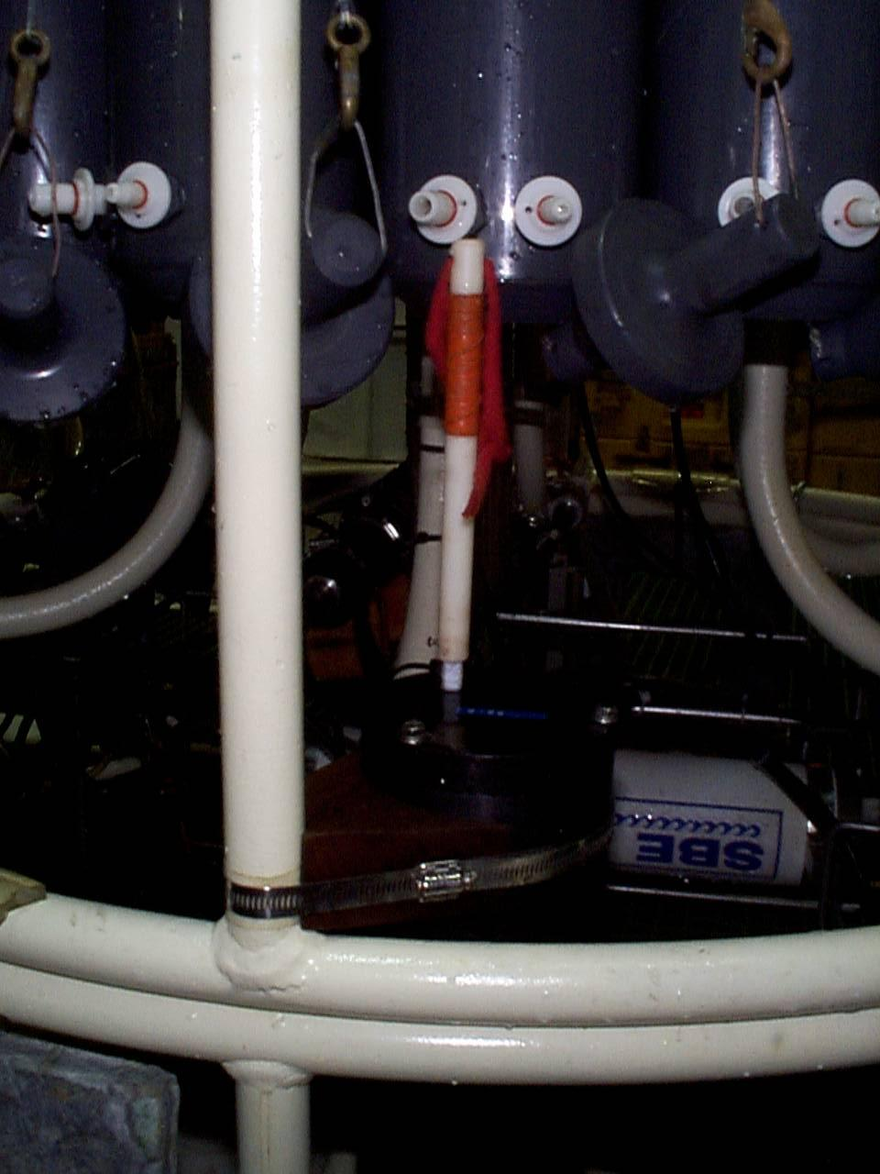
magnet on pinger
- Notify the Bridge and the Dry Lab that the package is in the water.
- Replace the safety chain over the door opening.
- Control is turned over to the Dry Lab.

Note: During the cast, ensure that the cable angle isn’t too stressed; if so, notify the Bridge. There may be ice floes that are in danger of snagging and snapping the cable; if possible and safe, keep these away by using the boat hooks located in the Baltic Room. Otherwise, notify the bridge and the mate on watch can clear it by subtle maneuvering.

Dry Lab
- When the Baltic Room is secure, turn on the deck unit (located forward of the SeaBird Computer on Rack 7). On the deck unit (s/n 490), the Word Count dial should be set to “E,” and the unit should read “0010.” On deck unit s/n 317, this setting is on “B.” The 1 indicates that that bottom contact line is hanging free (i.e., has tension on it). The last 0 indicates that the water pump is not on. Once the CTD package is in the water and the pump turns on, after 60 seconds, that should turn to “1.” Don’t start a cast without that indication.
- Start the audio tape data backup (below the deck unit) by pressing <REC>, then <Play>.
- Press F10 from the preliminary screen to display the data acquisition graph. Enter information on the header screen. Press <Esc>, then <Enter> to save the information and to display the graph. Depth is measured on the left, and, if specified in the Misc X-Y Plot Parameters, displayed in the bottom left-hand corner on the scan line of the screen.
- Take the unit down at about 30 meters per minute (m/m) until the temperature profile warms up (20-120m) in the pycnocline. This “soaking” equilibrates the sensors to the water temperature.
- Come back up as shallow as conditions permit (to 2m) in order to start the down cast. Before starting the down cast, record the scan number from the data line, or restart the .DAT file by pressing <CTRL+F1> and <F10> before starting the down cast. This wipes out the soak data so that it doesn’t have to be manually removed in the data processing.
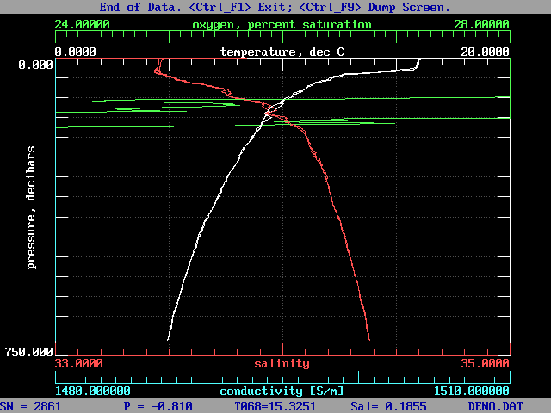
Display/Profile Graph
- Send the CTD package down at a speed appropriate for the depth of water (usually 55 meters/minute (m/m) in deeper water). This begins the “down trace.”
- Notify the Bridge that the CTD package is on its way down.
- Depths at which water will be collected can be picked to satisfy a variety of needs. For those targeting particular features in the water column, depths can be chosen and marked on the log sheet during the down trace. If you are not firing all bottles, plan to leave empty bottles symmetrically distributed to balance the weight on the rosette. Bottles are always fired on the up trace to maximize the quality of the down trace.
- If bottom water/data is needed, notify the winch operator when you’re close to the bottom; slow the winch to approx. 10 m/m. When the bottom contact weight has touched the bottom, the third digit of position E on the deck unit will turn from 1 to 0, and the scan line variable BCT will read YES. If an altimeter is installed on the package, it will give a distance to the bottom. Tell the winch operator to stop the winch.
- Once the CTD is on its way up and bottles are being fired, the package SHOULD NOT go back down (except for small distances).
- Notify the Bridge when the CTD package is on its way up.
- To fire a bottle:
- Notify the winch operator to slow the winch, then stop the winch at the desired depth.
- Press Ctrl+<F3> to fire a bottle; if the program is configured to fire bottles nonsequentially, you will be prompted at the top of the screen to input the bottle number. Type the number, and <Enter> to balance the weight on the rosette if not firing all the bottles.
- The profile will mark where you fired bottle(s). The software will also generate a bottle file with pertinent information.
- When the CTD package gets above 100m, give a verbal warning to the Baltic Room. At about 20m, slow the winch to approx. 20 m/m.
- Once the last bottle is fired (usually around 5 to 10m), continue coming up very slowly (approx. 10 m/m or less) until the Baltic Room confirms visual contact.
- Turn winch control over to the Baltic Room to bring the package on board. Notify winch controller and Baltic Room.
NOTE: It is IMPERATIVE to be clear on who has control of the CTD package (i.e., who is instructing the winch operator).
- Once the CTD package is out of the water, exit the software by pressing Ctrl+<F1>, and saving the file as prompted. Always exit the software before you turn off the deck unit.
- Turn off deck unit.
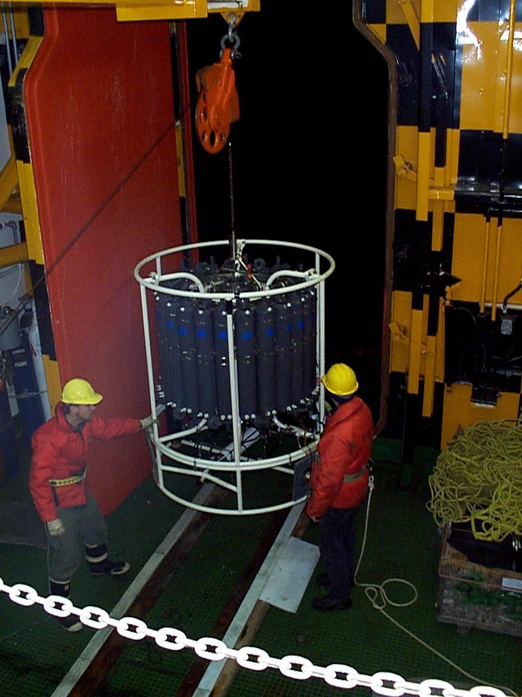
bringing in the CTD package
- Turn off audio tape backup.

Securing the CTD Package and Sampling
Baltic Room
- Be sure to communicate with the winch operator what is happening with the CTD package:
- When you can see the package (usually around 20m from the surface), point at your eyes.
- When the CTD breaks the surface of the water, make a horizontal motion with your hand across your waist.
- It is very important to bring the package into the Baltic Room as quickly as safety will allow. If the water on the sensors freezes, it can damage them. If in a swell, the longer time in the surface water increases the chances of a strong wave snapping the cable.
- Once the CTD package is on board, pull in the bottom finder/shackle before the Baltic Room door shuts. While it is closing, secure the CTD package by attaching the rope on front (door side) and the strap on the rear (winch side).
- Notify the Bridge that the door is closed and the package is secure.
- To finish securing the package:
- Replace Pinger magnet.
- Hose off the package with fresh water to prevent salt build-up, especially the trigger mechanisms on the pylon at the top-center of the rosette.
- Reconnect the temperature sensor tubes, and fill with distilled water.
- Use compressed air to blow out any water/ice from the pylon.
- Science groups should be encouraged to optimize sampling time between stations. Plan sampling order prior to the return of the package to the Baltic Room.

Data Back-Up
- After exiting the software, log on to the network by typing
net
at the C:\SEASOFT4.234> prompt, and press <Enter>.
A lot of information will scroll by, and then you will be prompted to enter a password. Type
DTC
and press Enter.
(NOTE: This may change from cruise to cruise.)
- At the P:\> prompt, type
C:
which should bring you to the C:\SEASOFT4.234> prompt.

- Copy the data files associated with that particular cast by typing
copy <filename>.* P:\CTD
and press <Enter>.
This should copy four files with extensions .DAT, .BL, .HDR, .CON. You will get an on-screen confirmation that looks like this:

<FILENAME>.DAT
<FILENAME>.BL
<FILENAME>.HDR
<FILENAME>.CON
4 file(s) copied

- Make another backup of the files by typing
copy <filename>.* H:\CTD
and press Enter.
Wait for the same confirmation as #3.
- At the C:\SEASOFT4.234> prompt, type
unnet
and press Enter to log off the network.
- Copy the files from P:\ to a removable media (such as a ZIP disk).

The data is now saved and backed up, and the computer is ready to be set up for the next station. Remove old (backed up) files from the C:\drive on the CTD computer, as the drive is small and will fill up easily.

