I. Setup of SEASOFT Software and Calibration of Instruments

About the CTD Package
The CTD package is comprised of a frame, onto which a rosette of bottles and various sensors are mounted. The types of sensors on the unit are variable depending on the needs of a particular cruise. Typically, there are always two temperature and conductivity sensors mounted on the CTD package. All of the sensors are connected to a central underwater unit (fish), which sends the data to the deck unit via the winch cable. The deck unit is connected to a PC on which the SEASOFT software is run during casts. Please see the diagram in Appendix G for wire run information.

About SEASOFT Software
The shipboard electronics used to acquire data from the CTD package has two components: the deck unit and the CTD computer. Both of these are located in the Forward Dry Lab. These are configured and operated with the SEASOFT software.
There are two main programs in the SEASOFT software package: the configuration program, and the acquisition/display program. Creating a configuration file allows SEASOFT to know what sensors the CTD package has, which data channels the sensors are on, and what constants and serial numbers the sensors have. Primarily, this configuration file is created by a seasoned user, though it is straightforward, and typically only needs to be done at the beginning of a cruise. If a sensor is changed during the cruise, then the configuration file must be changed to accommodate the new sensor.
This program runs from a DOS environment. A few navigational directions need to be understood to move around from screen to screen:
- <Esc> will back you out of a screen or “window” that you have been in. If you’ve changed information on that screen, the program will retain that information.
- Direction arrows <↑>, <↓>, <←>, <→> will navigate you from field to field within a screen.
- <Enter> is used to access a field or a screen, and to finish inputting information in the field.
- Other screen-dependent navigational directions are listed at the top and/or bottom of each screen or window displayed.

Creating a Configuration File
The SEASOFT software resides in the C:\SEASOFT4.234> directory. This directory reflects the latest version of the software, and should be changed when a new version of the software is installed.

- At the C:\SEASOFT4.234> prompt, type
SEACON
and press <Enter>.
- You should create a file specifically for your cruise. However, the easiest way to do this is to open one that exists, and modify from there. SEASOFT has a default file, SEACON.CON. Select the file, and press <Enter>. This will bring you to the Main Menu, which has two options:
- Change Instrument Configuration
- Change Calibration Coefficients

Changing Instrument Configuration
This section of the program identifies which sensors are connected to which frequency/voltage channel. Each channel passes the in-water measurements of a particular sensor to the deck unit and from there to the CTD computer for conversion to meaningful data values, such as temperature, conductivity, etc. For instance, if a temperature sensor is connected into Frequency 0, but the software thinks conductivity is connected to Frequency 0, the readings will be blatantly incorrect.
The CTD configuration needs to be changed only if different sensors have been added to the CTD package, or if assembling and configuring the package for the first time. Please refer to the diagrams of the endcaps of the underwater unit for the locations of frequency and voltage channels. Make a photocopy of the latest diagrams, with the sensor inputs labeled, to keep in the CTD log book for the cruise.
After selecting the instrument type (usually the SBE 911plus CTD), you’ll see the main screen.
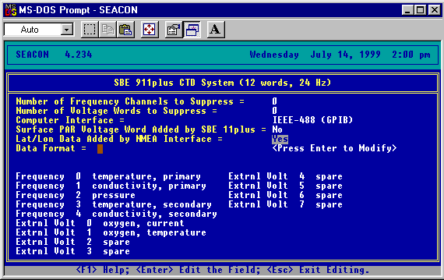
Changing Configuration Main Screen
The first half of the screen asks for information that typically won’t change.
Field | Data to Input/Explanation
Number of Frequency Channels to Suppress: | 0
Number of Voltage Words to Suppress: | 0
Computer Interface: | IEEE-488 (GPIB)
Surface PAR Voltage Word Added by SBE 911plus: | No
Lat/Lon Data Added by NMEA Interface | Typically, this is <Yes>, but if the GPS isn’t working, it has to be changed to <No> in order for the software to work.

The second half of the screen displays which sensors are currently connected to this CTD and what channel the sensors are plugged into. Highlight the DATA FORMAT field and press <enter> to change the assignment of a sensor to a different channel. Here are a few guidelines to assigning channels:
- Temperature and Salinity are always located on the frequency side of the underwater unit.
- The voltage side always contains the sea cable output(main power and communication) and the rosette input (which sends the message to fire bottles), in addition to any optional sensors added to the CTD package (e.g., oxygen sensor, flourometer, etc.).
- When acquiring data, if the software is having trouble reading a sensor, check the location listed on this screen, and the corresponding connection on the unit. Make sure the sensor is plugged into the same place that the computer is reading it from.
- Pressing <Esc> will back you out of all the screens, until you are asked to save the file. Save the file under the name/number of your cruise (or any other naming convention adopted) with a .CON extension.

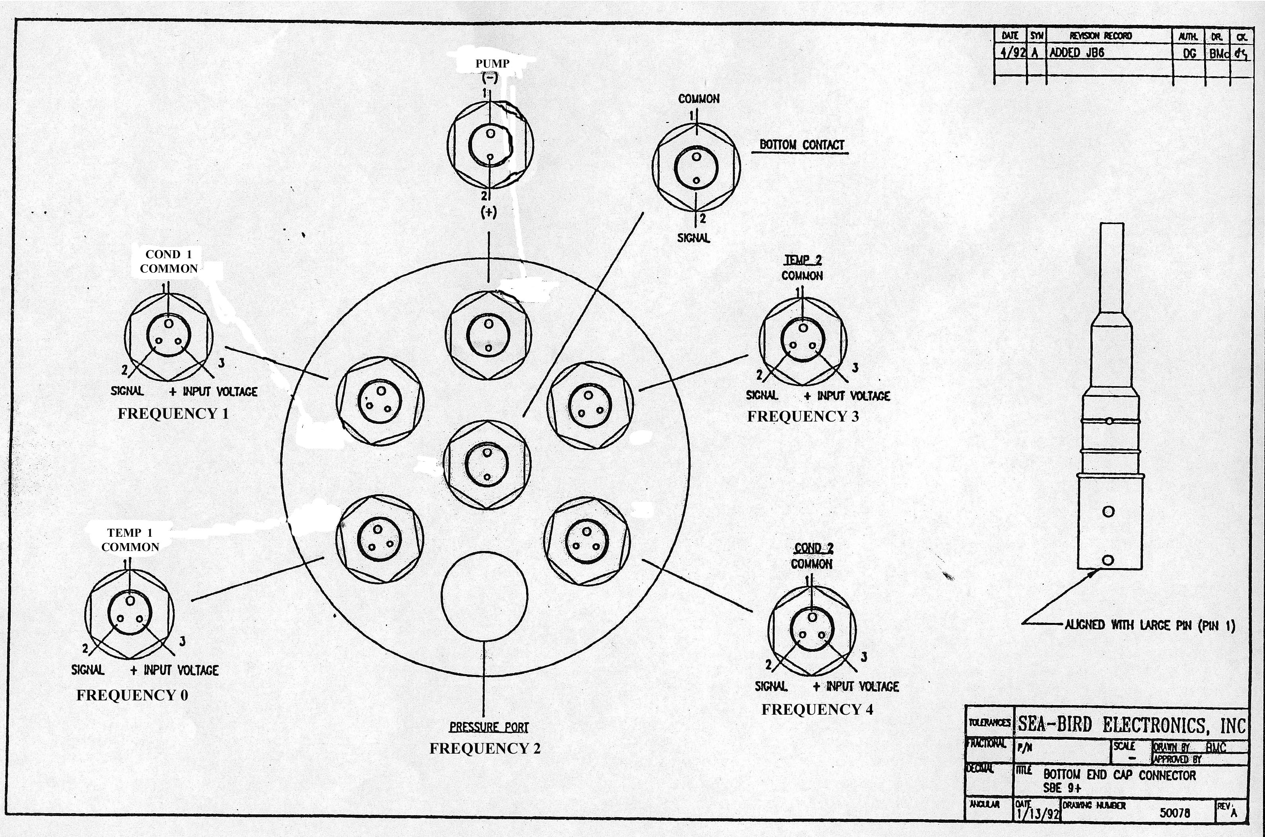
Frequency End Cap

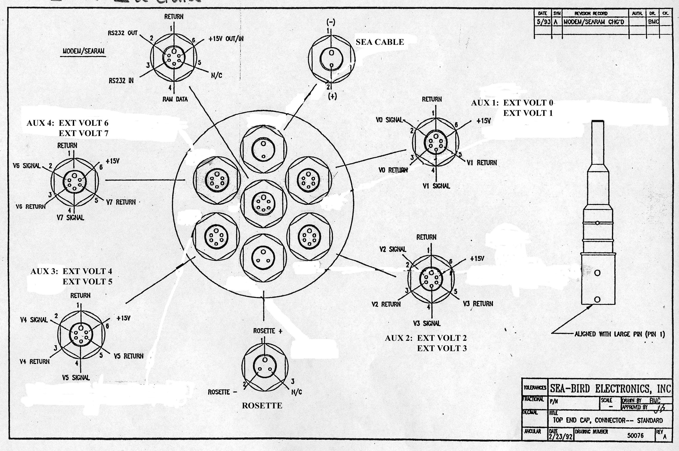
Voltage End Cap
Note: Typically, Oxygen goes on Voltage 0 (Current) and Voltage 1 (Temperature). For information on other sensors, please see Appendix G.

Changing the Calibration Coefficients
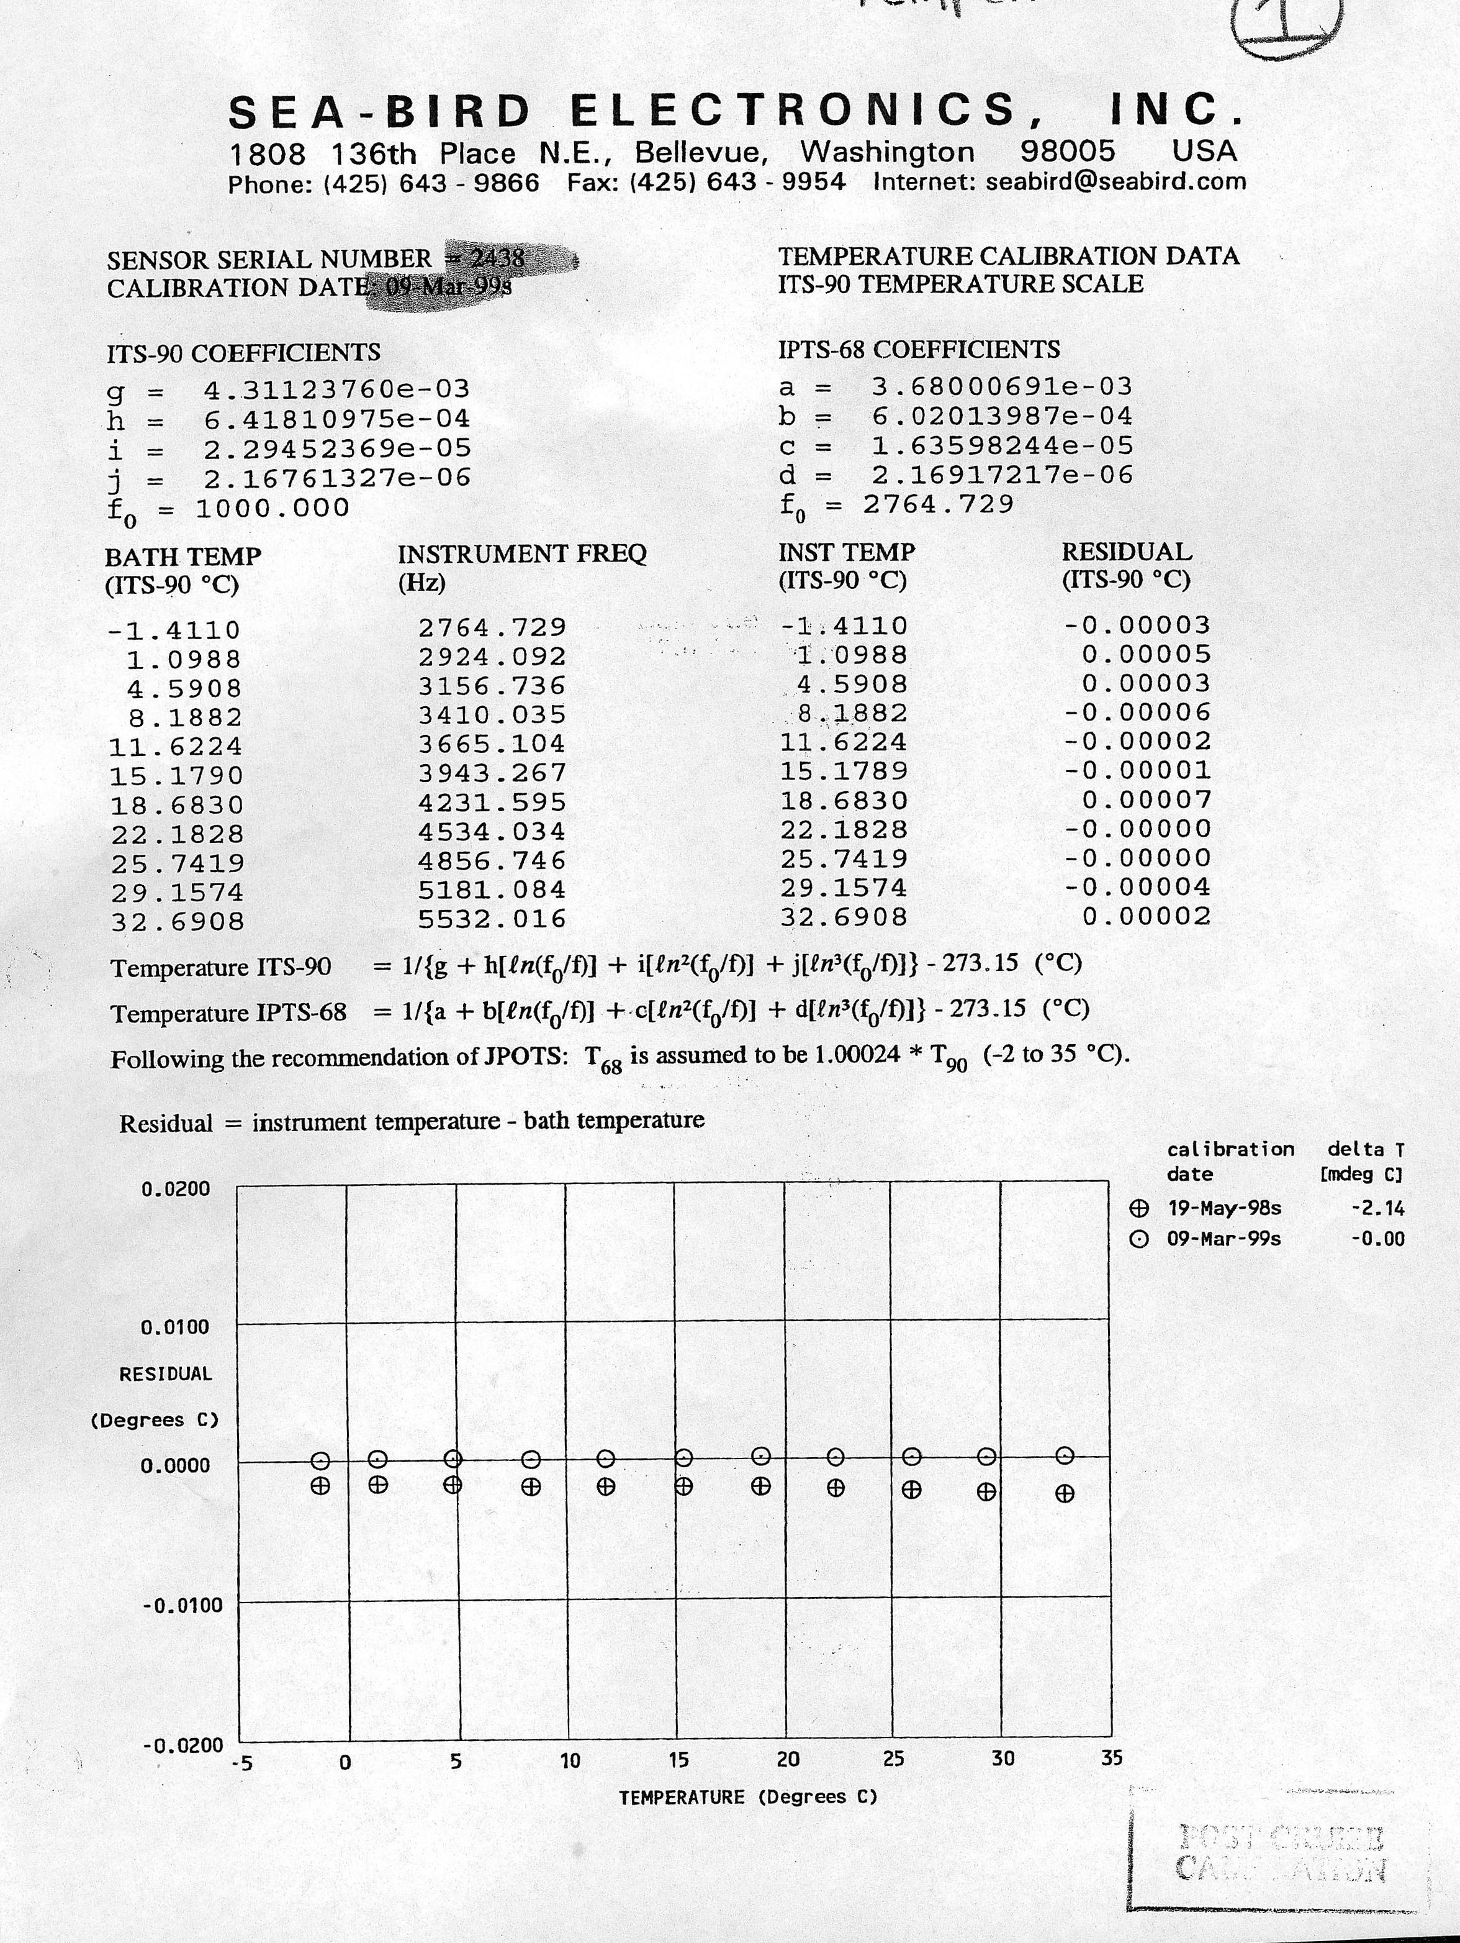
Calibration sheet for a temperature sensor
To ensure the raw data (frequencies or voltages) are converted to meaningful quantities by the SEASOFT software, it is necessary that the latest calibration constants are being used (i.e., are stored within the configuration file). This section of the .CON file must be checked for accuracy or changed to reflect the last calibration of each sensor. For each sensor, there should be a calibration sheet on record in the Instrument Calibration binder located in the ET office.
Pre-cruise, check each sensor for their serial numbers, and find their latest calibration sheet. Make a photocopy of each calibration sheet and place in the CTD log book for the cruise. Check these calibration constants against the ones which appear in the software.
- From the main screen of the .CON file, choose Change the Calibration Coefficients. A list of sensors will be displayed. The only sensors that are listed are the ones which were identified in the instrument configuration (.CON) file.
- By pressing <Enter> on the desired instrument, you can check the calibration coefficients by choosing that option and pressing <Enter> again.
- The current coefficients will be listed. To change them, highlight the desired field to be edited, and press <Enter>. It helps to have someone read the numbers off of the calibration sheets to the person inputting the data. Press <Enter> again once the data has been input.
Make sure to save this file before you exit the software.

Testing the Calibration
There is an in-air test for accuracy on pages 4-5 in the Operations and Repair Manual for the CTD package, located above the CTD terminal. This test only lets you check the frequency channels. This test runs directly through the deck unit, and does not use the software.
- Power up the unit by turning on the deck unit power switch, and set the thumbwheel to the various settings listed below. The values that appear in the deck unit’s digital display window should be within the specified range when the CTD is not in the water:

Thumbwheel Position | Instrument Indicated | Display Range
0 | primary temperature | 9,000-11,000 Hz
1 | primary conductivity | approx. 2,800 Hz
2 | pressure sensor | 32,000-40,000 Hz
3 | secondary temperature | 9,000-11,000 Hz
4 | secondary conductivity | approx. 2,800 Hz
5 | A/D converter | The four digits to the left represent converter channel 0; to the right, channel 1

- Power down the unit when this testing is completed.
- If a problem exists with a sensor (or its connection to the deck unit via the fish), the reading will be dramatically inconsistent with the parameters specified by the manual and in the table above. It also could mean that the .CON file is wrong (e.g., temperature is in the conductivity channel).
If there are any problems evident through this test, contact the Electronics Technician (ET) on board.

Backing Up Configuration (.CON) Files
Each time you deploy the CTD, the data collected gets saved in a .DAT file. When a new .DAT file name is created, SEASOFT makes a new configuration file based on the configuration file it used with that particular station. For instance, for cast 013, the data will be collected in a file named CTD013.DAT (or whatever the operator names it); SEASOFT will create a file, CTD013.CON, which is the same as the .CON file used for that particular cast. This ensures that when the data is analyzed, there is back-up information to indicate which instruments and which calibration coefficients were used for that particular cast. Keep the backup .CON file with the .DAT file for ease in future processing.
If you need to change instruments mid-cruise, make sure to create a new .CON file and save it with a new name.

