CTD Operations

NATHANIEL B. PALMER

July 1999
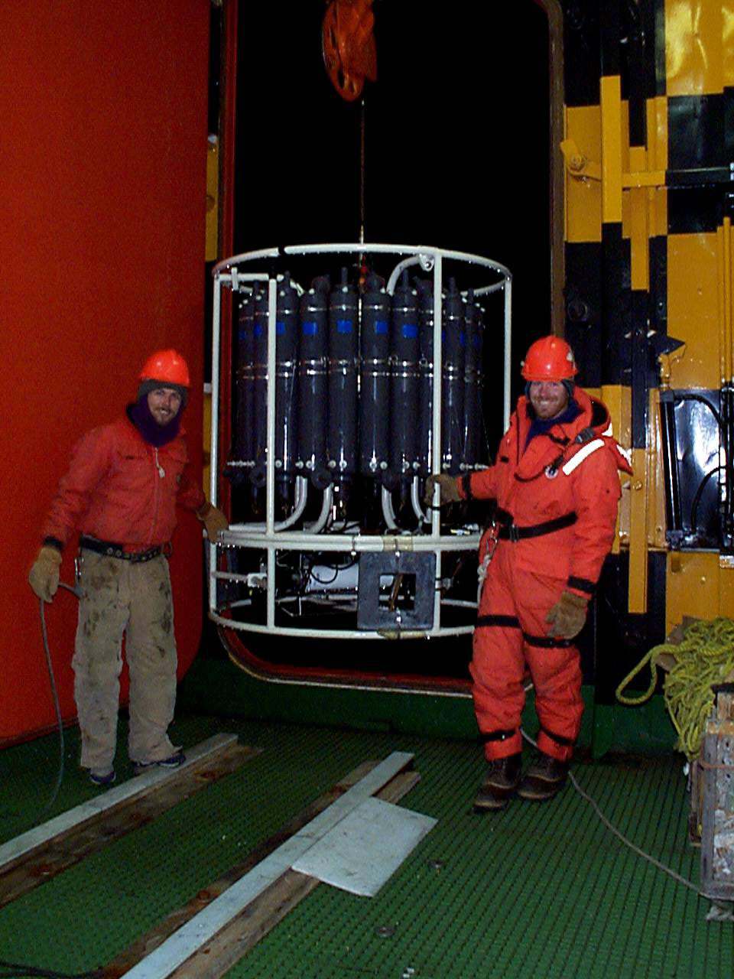

Prepared by Antarctic Support Associates
61 Inverness Drive East, Suite 300
Englewood, CO 80112
303-790-8606
TABLE OF CONTENTS

Introduction
I. Setup of SEASOFT Software and Calibration of Instruments
About the CTD Package
About SEASOFT Software
Creating a Configuration File
Changing Instrument Configuration
Changing the Calibration Coefficients
Testing the Calibration
Backing Up Configuration (.CON) Files
II. Deploying the CTD Package
Pre-Cast
Cast Procedure
Securing the CTD Package and Sampling
Data Back-Up
III. Documentation
IV. Post-Processing/Data Analysis
V. Using the Autosalinometer to Check Data Accuracy
About the Autosalinometer
Starting the Autosal Process
Standardizing the Autosal
Analyzing Samples
Finishing a Run
Documentaiton
Converting Conductivity Ratios to Salinity
Running the Portasal
Troubleshooting
VI. Troubleshooting the CTD

List of Appendices

Appendix A: List of Display Files
Appendix B: Dry Lab Instructions for Casting the CTD
Appendix C: Baltic Room Instructions for Casting the CTD
Appendix D: Instructions for running the Portasal
Appendix E: Salts Sampling Techniques
Appendix F: Casting Checklists
Appendix G: Sensor Information
Appendix H: On Board References
Appendix I: Pictoral Glossary

