Appendix I: Pictorial Glossary

The images and definitions below are provided to help identify certain parts on the CTD package.

Autosal/Portasal | Salinometer instruments which measure conductivity and salinity.
Bleed Valve | White screw at the top of the bottle which allows air into the bottle for water flow through the spigots.
Bottle | Container on the rosette which captures and holds water. See picture below for details on the bottle.
Bottle Stop | The top and bottom lids of the bottles.
Bottom Contact | A mechanism on the underwater unit which is attached to a weight by a 10m length of twine. When the weight hits the bottom, a circuit is closed and a signal sent to the deck unit.
Channel (voltage word, frequency channel) | The location where the sensors are plugged into the underwater unit and where the deck unit reads data from.
Deck Unit | The central receiver of data from the underwater unit.
Fire/Trip | To close a bottle.
Fish | Another name for the underwater unit
Lanyard | Sturdy plastic wire, looped at the end to load into the pylon. This keeps the bottle cocked.
O-Ring | A rubber ring that ensures the bottle has a water-tight seal. See pictures below for directions on replacing an O-ring.
Pinger | The sonar bottom sensor located on the rosette.
Pylon | The top of the rosette where the lanyards on the bottles are loaded for firing. See picture below.
Rosette | The round carousel which houses the bottles, sensors, and the Seabird underwater unit.
Spigots | Located at the bottom of the bottle, the spigots allow water to flow out of the bottle at a controlled rate.
Trace | The collected data as a function of depth.
Underwater Unit | The central sensor located on the bottom of the rosette. This houses the pressure sensor and is connected to other sensors located on the rosette. It also is the main connection to the winch (sea) cable.

Pictures

Bottle
Below is an image of three bottles, with their parts identified.

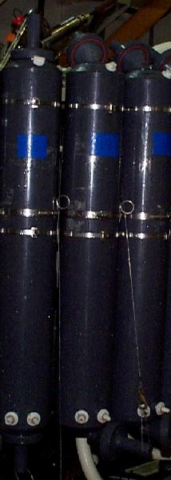
O-Ring
Bleed Valve
Spigots
Lanyard and clip
Bottom bottle stop
Top bottle stop

O-Ring

To replace an O-ring, follow these steps:

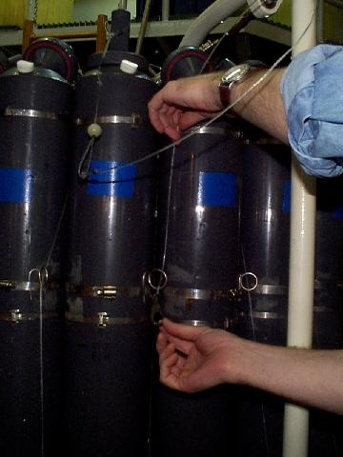 | 1. Remove lanyard from metal loop holder.
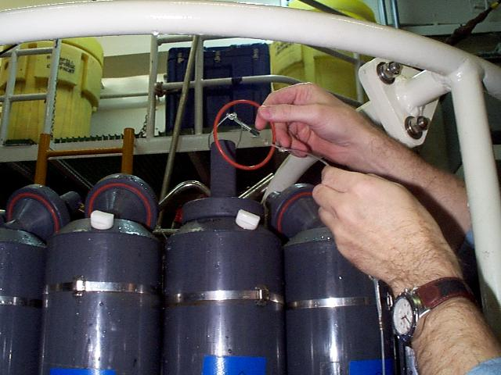 | 2. Slip O-ring over the top bottle stop. Cock the bottle stop open.
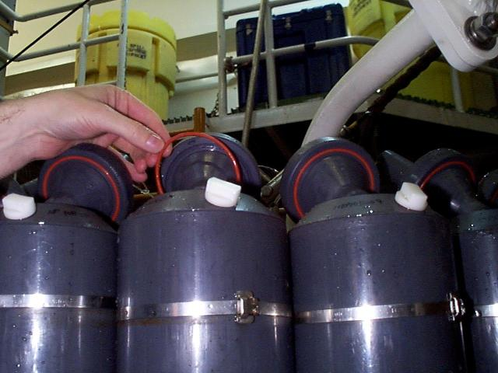 | 3. Seat the O-ring, starting at the bottom of the bottle stop.
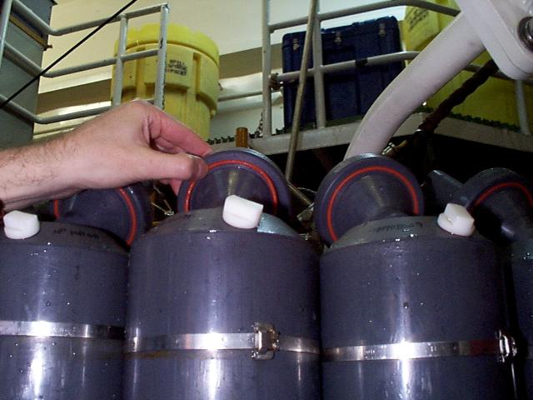 | 4. Using your thumbs, press the ring into its seat from bottom to the top of the bottle stop.
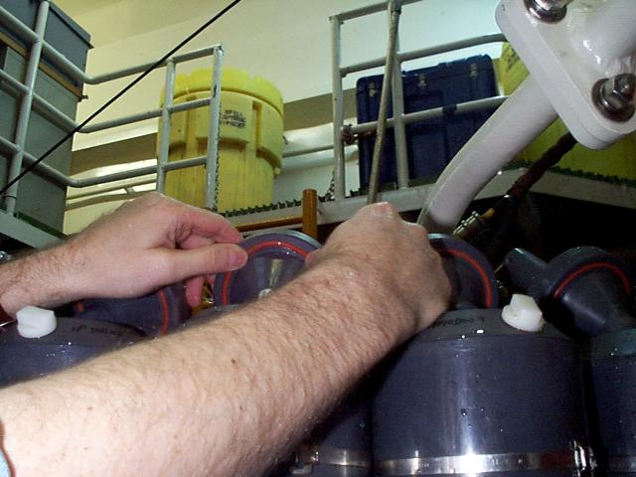 | 5. There will be a small slack left when you reach the top. Relax your thumbs, and the O-ring will slip into its seat. Press to make sure it fits snugly.

Rosette

The rosette is the frame which carries the bottles and the sensors, including the underwater unit. The current rosette on the NBP is a 24-bottle rosette. The LMG currently uses a 12-bottle rosette.

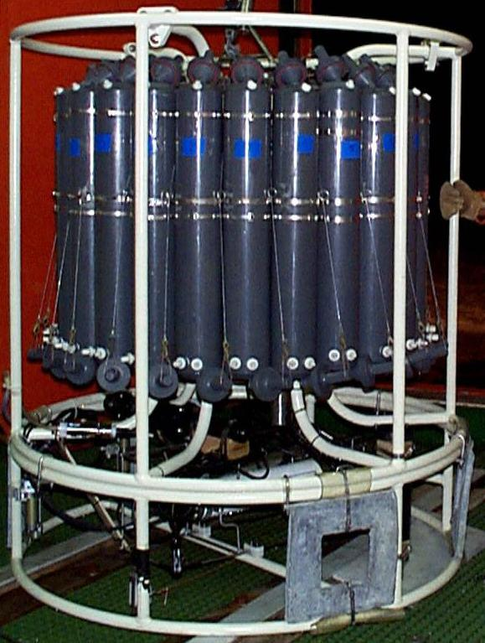
24-bottle rosette

The top of the rosette contains the pylon, which is made up of 1 trigger for each bottle. This is the place to attach the lanyards in order to cock the bottles. The small hook on top of the trigger is pushed in to prepare to cock the bottles.

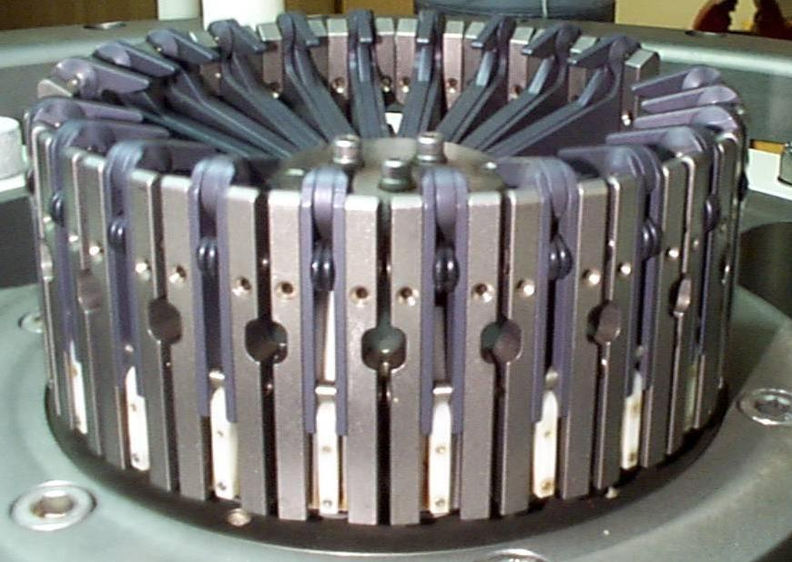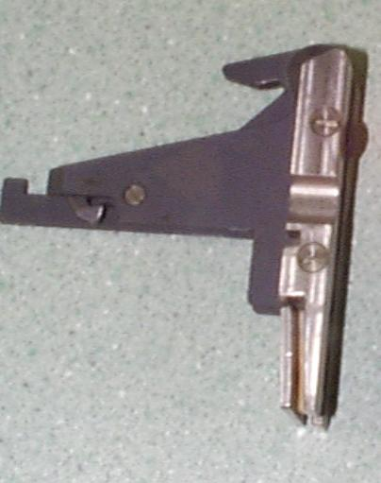
Cocked pylon Trigger

Below is an image of a pylon removed from the rosette, and half-cocked. Also, a pylon attached to the rosette, cocked with lanyards attached to bottles.

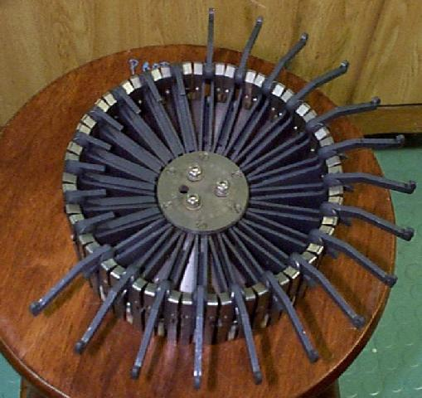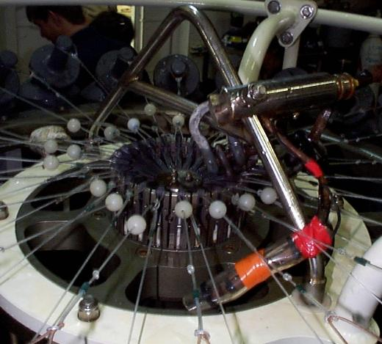
Half-cocked pylon Fully cocked pylon with lanyards attached

Underwater Unit (Fish) and Sensors

A variety of sensors can be mounted on the CTD package. Below are pictures of a fish and a temperature/conductivity pair already mounted.

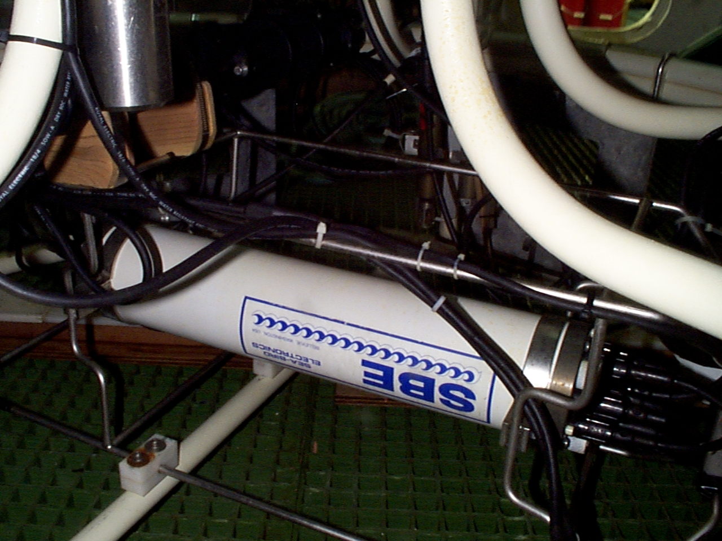
Fish

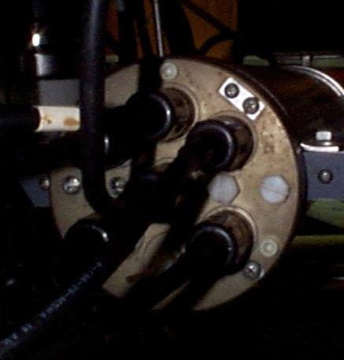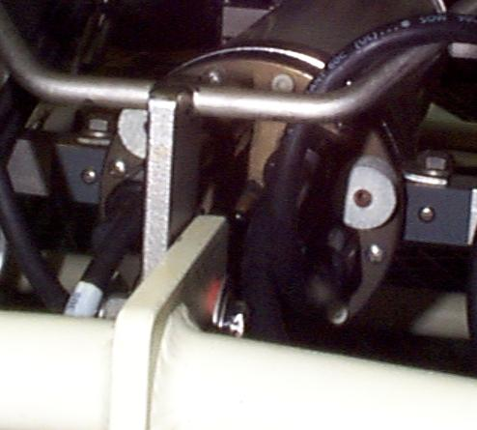
Frequency end of fish Voltage end of fish

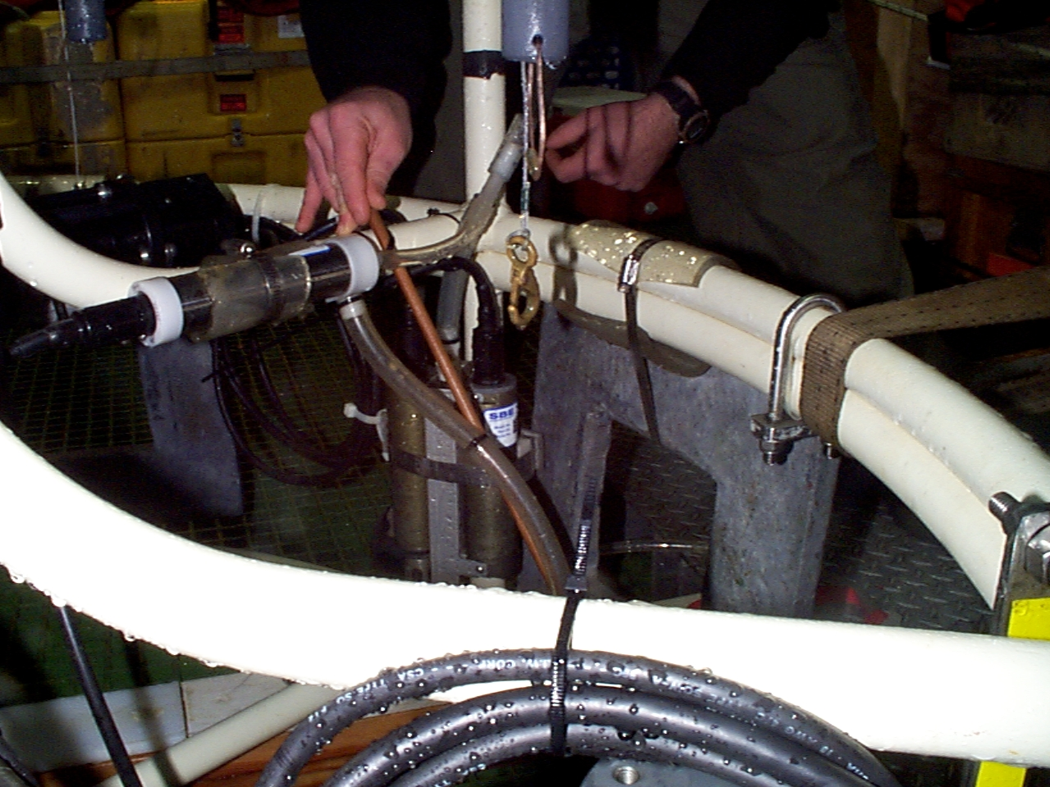
Pump
Temperature/
Conductivity
sensors
Temperature, Conductivity Sensor and Pump

Autosalinometer and Portasal

The Autosal and Portasal differ in a number of ways. Below is a labeled image of both.

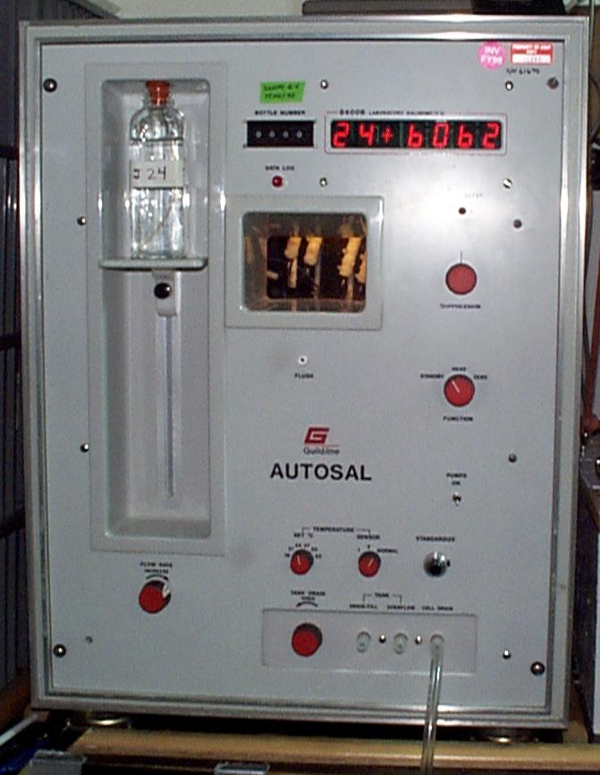
Display
Suppression dial
Function Switch
Sample Bottle
Adjustable sample table
Flow rate
Flush valve
Temperature adjustment
Standardize dial
Cell Outflow

Portasal

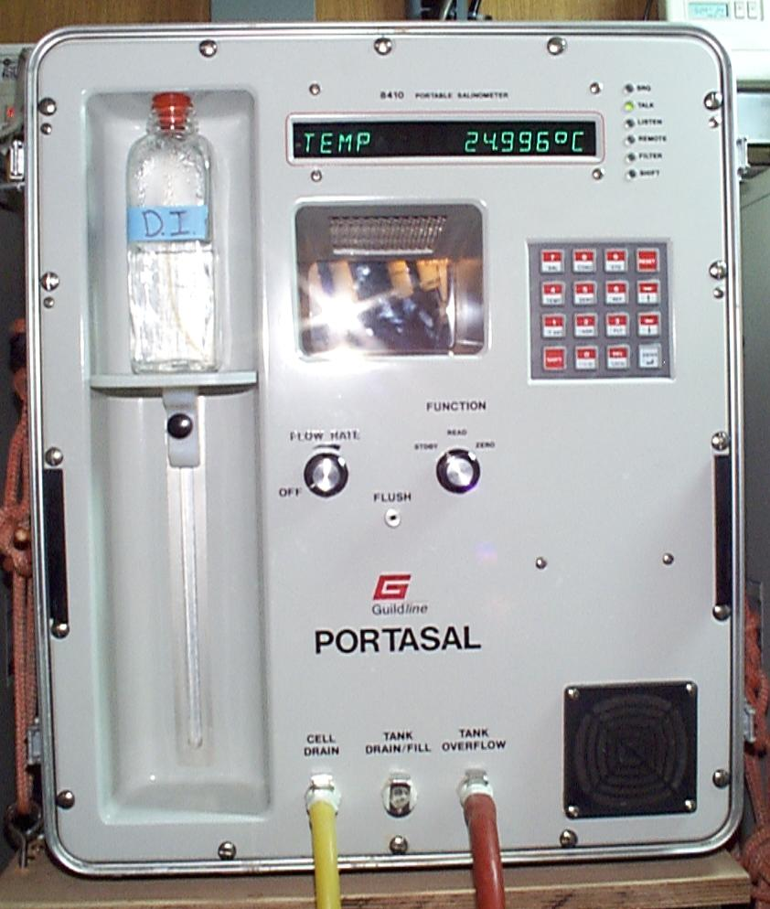
Display
Function Switch
Cell Outflow
Sample Bottle
Adjustable sample table
Flow rate
Flush valve
Keypad

