Appendix G: Sensor Information

Underwater Unit Information

The underwater unit (fish) is cylindrical and has channels on both ends to connect to the sensors. One end holds frequency channels, the other holds voltage channels, or words. The difference is in how the data is reported to the deck unit.

Electronic Connection Diagram
Winch Slip Ring

GPS
T

S

Underwater Unit/Fish

Deck Unit

O

PC/ SEASOFT
Terminal

F

Sensors

Key:

Seabird cable*:
.322 armored electromechanical cable:
Coaxial cable:
Serial cable

*there are various types of cables from sensors. See their own documentation for more information.

Water Flow Information

To better understand the underwater unit (fish) and what water the sensors are getting their information from, below is a diagram of the water flow through the sensors. Please note that other sensors may get water flow a different way.

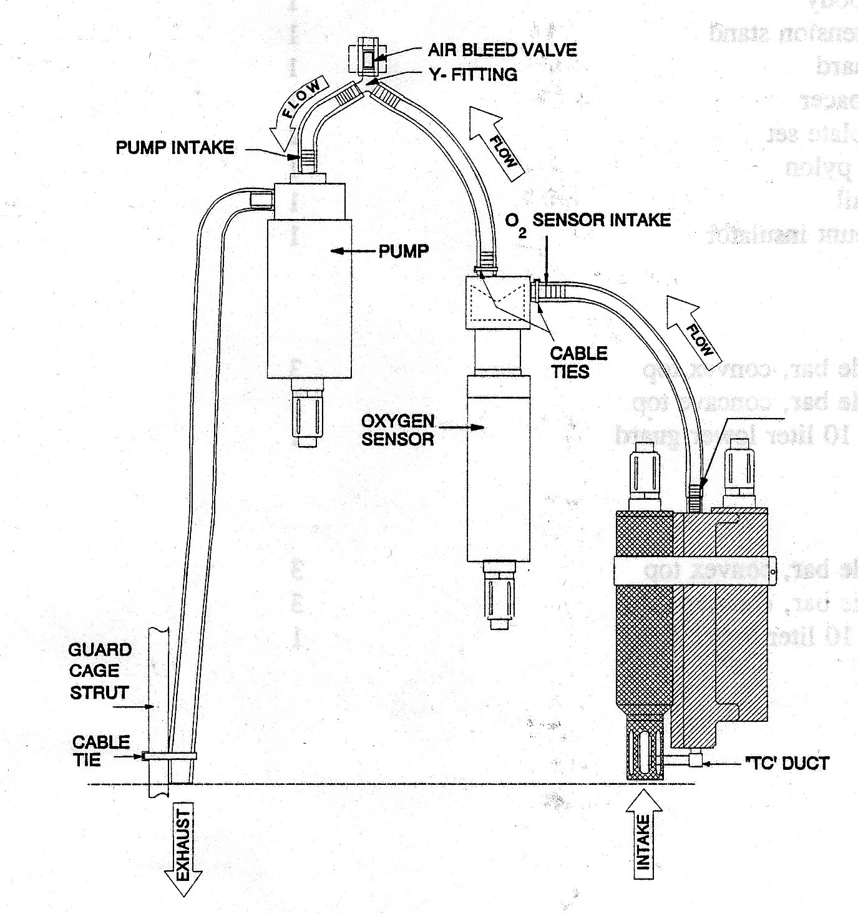
Temperature Sensor

Conductivity Sensor
*Diagram taken from SeaBird Underwater Unit documentation

The unit knows a precise flow rate, and from that, accurately calculates temperature, salinity, and oxygen. Thus, if even a small piece of ice, slush, or other contaminant gets into the tubing or ductwork, it will alter the flow rate and degrade the calculation.

Sensor Variability

The CTD package and underwater unit was designed to hold a variety of different sensors. The CTD package documented here included dual temperature and salinity sensors, a dissolved oxygen sensor, a flourometer, scatterometer, transmissometer, and altimeter.. It is possible to mount and read different sensors, such as a PAR, altimeter, etc. There are a number of empty voltage plugs on the underwater unit to accommodate these sensors. Please refer to the diagrams (shown in section 1) of the end caps of the underwater unit for available voltage plugs.

When mounting the sensors, please refer to the manufacturer’s directions.

