Appendix C: Dry Lab Instructions for Casting the CTD Package

About SEASOFT Software
This program runs from a DOS environment. A few navigational directions need to be understood to move around from screen to screen:

- <Esc> will back you out of a screen or “window” that you have been in. If you’ve changed information on that screen, the program will retain that information.
- Direction arrows <↑>, <↓>, <←>, <→> will navigate you from field to field within a screen.
- <Enter> is used to access a field or a screen, and to finish inputting information in the field.
- Other screen-dependent navigational directions are listed at the top and/or bottom of each screen or window displayed.

Pre-Cast Procedure

Dry Lab

- Record the event or station number for this cast. On some cruises, it may be necessary to call the Bridge to get an event number.
- On the SeaBird computer, at the C:\SEASOFT4.234> prompt, type
seasave
and press <Enter>.
- From the Main Menu, select “Acquire and Display Real-Time Data” and press <Enter>.
- Preliminary Screen:
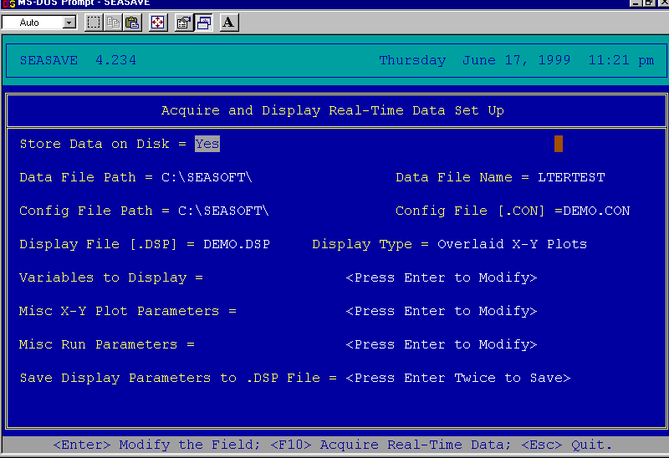

- FILE NAME: Change file name (e.g., LTERTEST.DAT) for this particular cast.
- DISPLAY FILE: Change the display file for the cast type (usually for the depth range). Please see Appendix A for a list of display files.
- VARIABLES TO DISPLAY: Adjust the variables you want to display by choosing temperature, conductivity, etc.—whatever you want to see plotted during the actual cast.
- MISC X-Y PLOT PARAMETERS: These are the scan line variables. The scan line is displayed at the bottom of the screen during a cast, and can display data in numbered form. Press X—your choice, for instance, the altimeter (if it’s on the package), or BCT (Bottom Contact).
- If you change any of the settings in VARIABLES TO DISPLAY, MISC X-Y PLOT PARAMETERS, or MISC RUN PARAMETERS, you may wish to save those settings in a new display file. To do this, select Save Display Parameters to .DSP File at bottom of the screen, and press <Enter> twice. Name your customized display file.

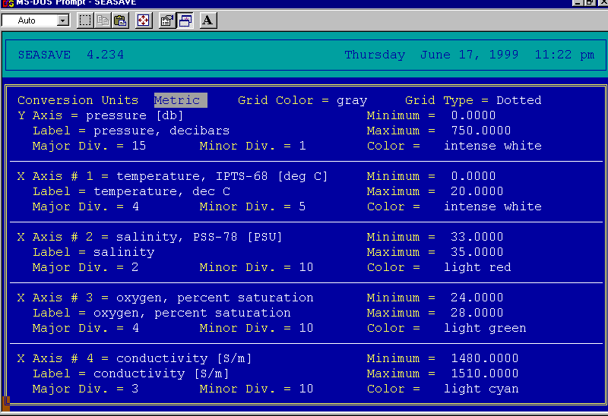
Variables to Display Screen

Casting Procedure

Dry Lab
- When the Baltic Room is secure, turn on the deck unit (located forward of the SeaBird Computer on Rack 7). On the deck unit (s/n 490), the Word Count dial should be set to “E,” and the unit should read “0010.” On deck unit s/n 317, this setting is on “B.” The 1 indicates that that bottom contact line is hanging free (i.e., has tension on it). The last 0 indicates that the water pump is not on. Once the CTD package is in the water and the pump turns on, after 60 seconds, that should turn to “1.” Don’t start a cast without that indication.
- Start the audio tape data backup (below the deck unit) by pressing <REC>, then <Play>.
- Press F10 from the preliminary screen to display the data acquisition graph. Enter information on the header screen. Press <Esc>, then <Enter> to save the information and to display the graph. Depth is measured on the left, and, if specified in the Misc X-Y Plot Parameters, displayed in the bottom left-hand corner on the scan line of the screen.
- Take the unit down at about 30 meters per minute (m/m) until the temperature profile warms up (20-120m) in the pycnocline. This “soaking” equilibrates the sensors to the water temperature.
- Come back up as shallow as conditions permit (to 2m) in order to start the down cast. Before starting the down cast, record the scan number from the data line, or restart the .DAT file by pressing <CTRL+F1> and <F10> before starting the down cast. This wipes out the soak data so that it doesn’t have to be manually removed in the data processing.
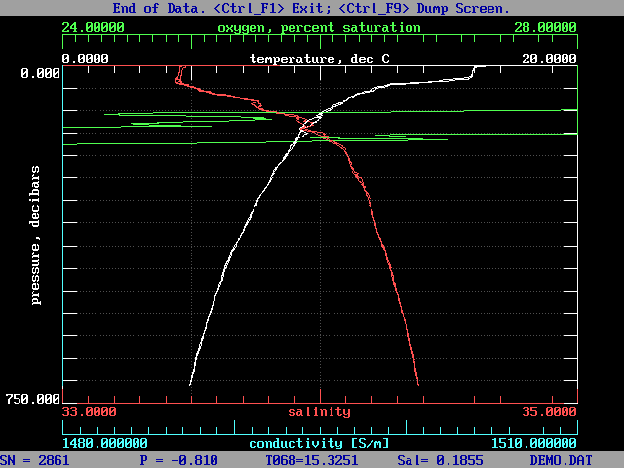
Display/Profile Graph
- Send the CTD package down at a speed appropriate for the depth of water (usually 55 meters/minute (m/m) in deeper water). This begins the “down trace.”
- Notify the Bridge that the CTD package is on its way down.
- Depths at which water will be collected can be picked to satisfy a variety of needs. For those targeting particular features in the water column, depths can be chosen and marked on the log sheet during the down trace. If you are not firing all bottles, plan to leave empty bottles symmetrically distributed to balance the weight on the rosette. Bottles are always fired on the up trace to maximize the quality of the down trace.
- If bottom water/data is needed, notify the winch operator when you’re close to the bottom; slow the winch to approx. 10 m/m. When the bottom contact weight has touched the bottom, the third digit of position E on the deck unit will turn from 1 to 0, and the scan line variable BCT will read YES. If an altimeter is installed on the package, it will give a distance to the bottom. Tell the winch operator to stop the winch.
- Once the CTD is on its way up and bottles are being fired, the package SHOULD NOT go back down (except for small distances).
- Notify the Bridge when the CTD package is on its way up.
- To fire a bottle:
- Notify the winch operator to slow the winch, then stop the winch at the desired depth.
- Press Ctrl+<F3> to fire a bottle; if the program is configured to fire bottles nonsequentially, you will be prompted at the top of the screen to input the bottle number. Type the number, and <Enter> to balance the weight on the rosette if not firing all the bottles.
- The profile will mark where you fired bottle(s). The software will also generate a bottle file with pertinent information.
- When the CTD package gets above 100m, give a verbal warning to the Baltic Room. At about 20m, slow the winch to approx. 20 m/m.
- Once the last bottle is fired (usually around 5 to 10m), continue coming up very slowly (approx. 10 m/m or less) until the Baltic Room confirms visual contact.
- Turn winch control over to the Baltic Room to bring the package on board. Notify winch controller and Baltic Room.
NOTE: It is IMPERATIVE to be clear on who has control of the CTD package (i.e., who is instructing the winch operator).
- Once the CTD package is out of the water, exit the software by pressing Ctrl+<F1>, and saving the file as prompted. Always exit the software before you turn off the deck unit.
- Turn off deck unit.
- Turn off audio tape backup.

Data Back-Up
- After exiting the software, log on to the network by typing
net
at the C:\SEASOFT4.234> prompt, and press <Enter>.
A lot of information will scroll by, and then you will be prompted to enter a password. Type
DTC
and press <Enter>.
(NOTE: This may change from cruise to cruise.)
- At the P:\> prompt, type
C:
which should bring you to the C:\SEASOFT4.234> prompt.

- Copy the data files associated with that particular cast by typing
copy <filename>.* P:\CTD
and press <Enter>.
This should copy four files with extensions .DAT, .BL, .HDR, .CON. You will get an on-screen confirmation that looks like this:

<FILENAME>.DAT
<FILENAME>.BL
<FILENAME>.HDR
<FILENAME>.CON
4 file(s) copied

- Make another backup of the files by typing
copy <filename>.* H:\CTD
and press <Enter>.
Wait for the same confirmation as #3.
- At the C:\SEASOFT4.234> prompt, type
unnet
and press <Enter> to log off the network.
- Copy the files from P:\ to a removable media (such as a ZIP disk).

The data is now saved and backed up, and the computer is ready to be set up for the next station. Remove old (backed up) files from the C:\drive on the CTD computer, as the drive is small and will fill up easily.

