Appendix B: Baltic Room Instructions for Casting the CTD Package

One of the most important aspects of a CTD cast is keeping constant communication between the Bridge, the Dry Lab, and the Baltic Room. A few safety notes for operation in the Baltic Room during the cast:

- Always wear a float coat or a mustang suit and a hard hat.
- Be connected to a tag line secured in the Baltic Room whenever the Baltic Room Door is open.

Pre-Cast
(1/2 hour before station)
- Cock the bottles (see Appendix I for bottle components):
NOTE: Some of the bottles may not be completely empty, so when you cock the bottom stop, water may come out.
- Unclip lanyards from bottom bottle stops.
- Close the triggers on the pylon in the top center of the rosette—push down each trigger until it clicks.
- Start with bottle 1. Open top stop so that the loop of the lanyard can fit over trigger numbered 1.
- Work around the rosette, cocking all the bottles on top.
- Open bottom stops, making sure to keep the lanyard clear of the spigots, and clip open to the bottom of the lanyard.
- Make sure the top bleed valves (white screws) are closed.
- Close all spigots on all bottles by pulling them out. The dials on the spigot should spin.
- Make a visual inspection of the CTD package, checking the following:
- All O-rings look well-seated on the bottles (top and bottom).
- All bleed valves and spigots are closed.
- Winch cable won’t catch on anything when the CTD package is deployed.
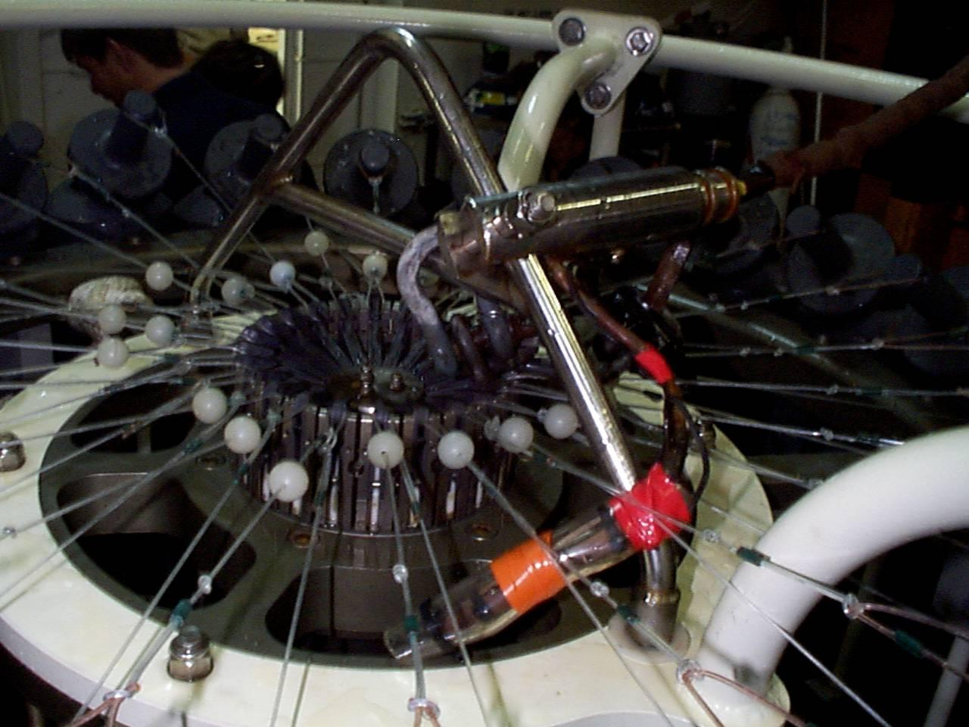
cocked rosette
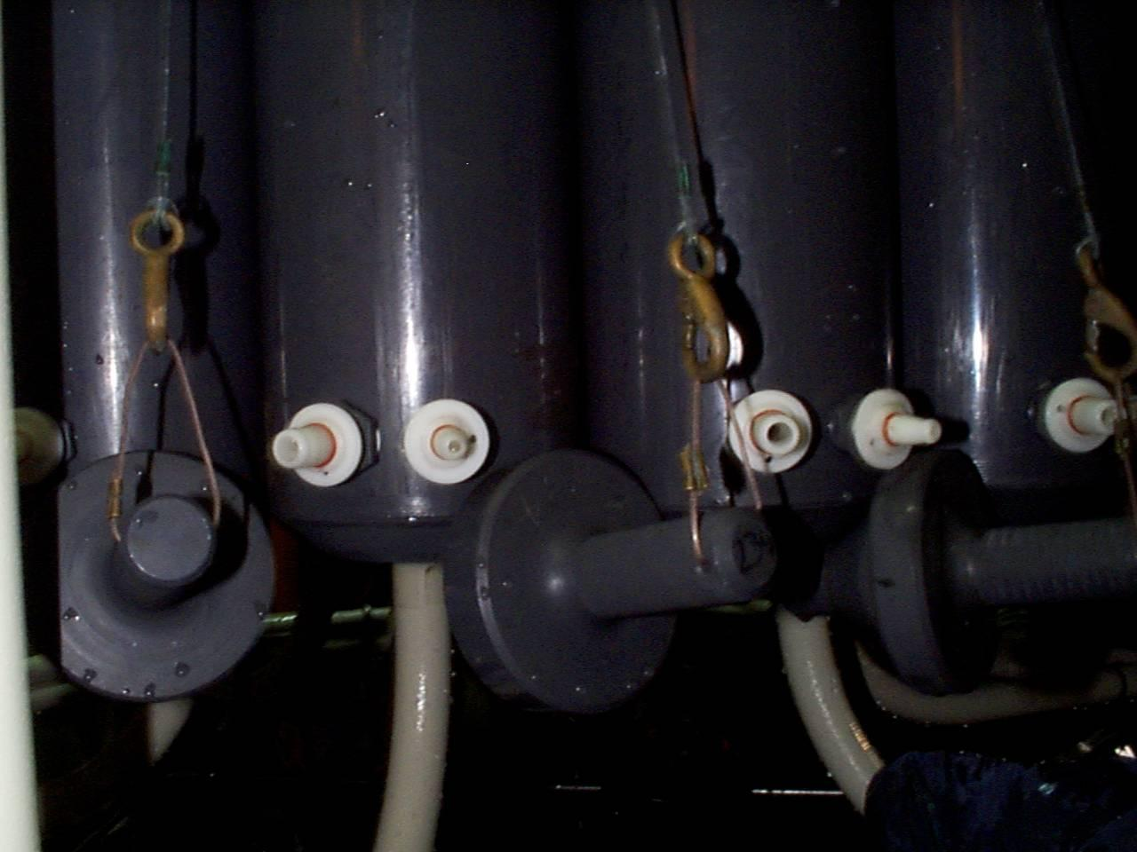
spigots on cocked bottle

Operating in Ice
Casting a CTD package in sea ice fields is very different from casting in open ocean. The instruments located on the bottom of the package are very sensitive, and can break easily, or become fouled, if frozen or hit by ice.
- If casting in a hole dug through pack ice, keep the hole clear of brash ice or slush as the package is going into and coming back up through the surface.
- The mate on watch will use the ship to create an opening in the ice and maintain the area free of ice.

There will be 3 people in the Baltic Room to perform a cast, typically comprised of one ASA employee (usually an MT), one scientist, and the winch operator (provided by ECO). Once these three people are inside, secure the Baltic Room by dogging all the interior doors. This must be done in order to open the Baltic Room door to deploy the CTD package.

NOTE: The CTD package should NEVER be put in the water with bottles closed and full of air. This will crush the bottles.
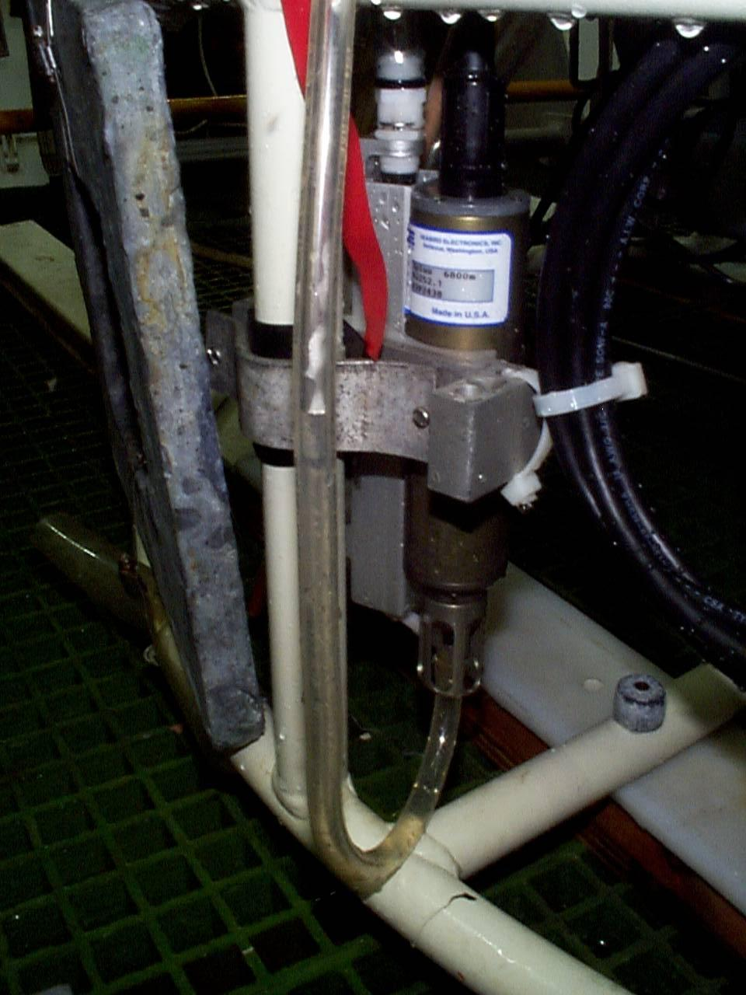
distilled water tube on temperature sensor
- Disconnect the distilled water tubes (marked with red ribbons) from the two temperature sensors by pulling them off.
- Turn on the pinger (bottom sensor) by pulling out the magnet marked with a red ribbon. It will start to ping.
- Unsecure the CTD package.
- The Bridge will give the word when it is safe to open the Baltic Room Door.
- The winch will move the CTD package toward the door.
- Throw the bottom contact line out before the CTD package goes out.
- The boom will move out first. Then the winch will lower the CTD in the water.
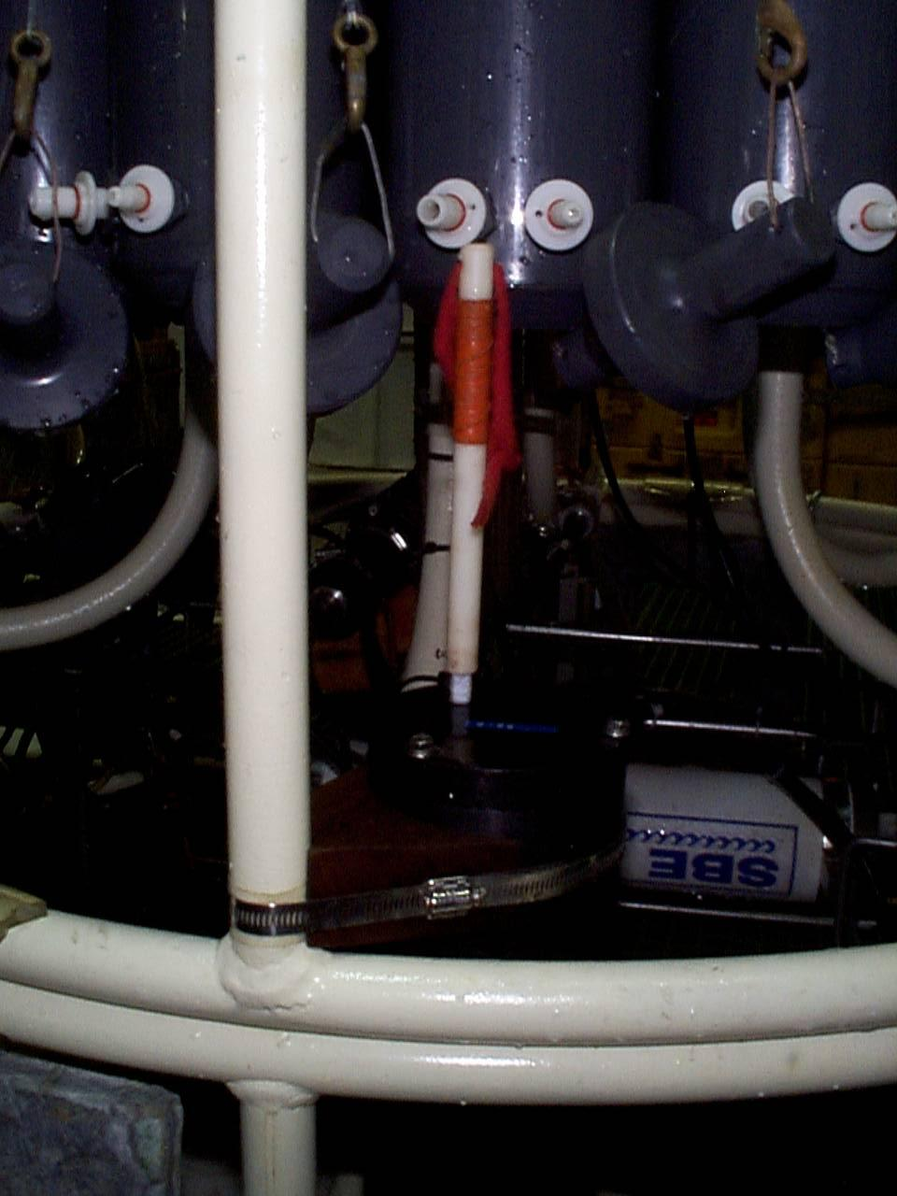
magnet on pinger
- Notify the Bridge and the Dry Lab that the package is in the water.
- Replace the safety chain over the door opening.
- Control is turned over to the Dry Lab.

Note: During the cast, ensure that the cable angle isn’t too stressed; if so, notify the Bridge. There may be ice floes that are in danger of snagging and snapping the cable; if possible and safe, keep these away by using the boat hooks located in the Baltic Room. Otherwise, notify the bridge and the mate on watch can clear it by subtle maneuvering.

Securing the CTD Package and Sampling
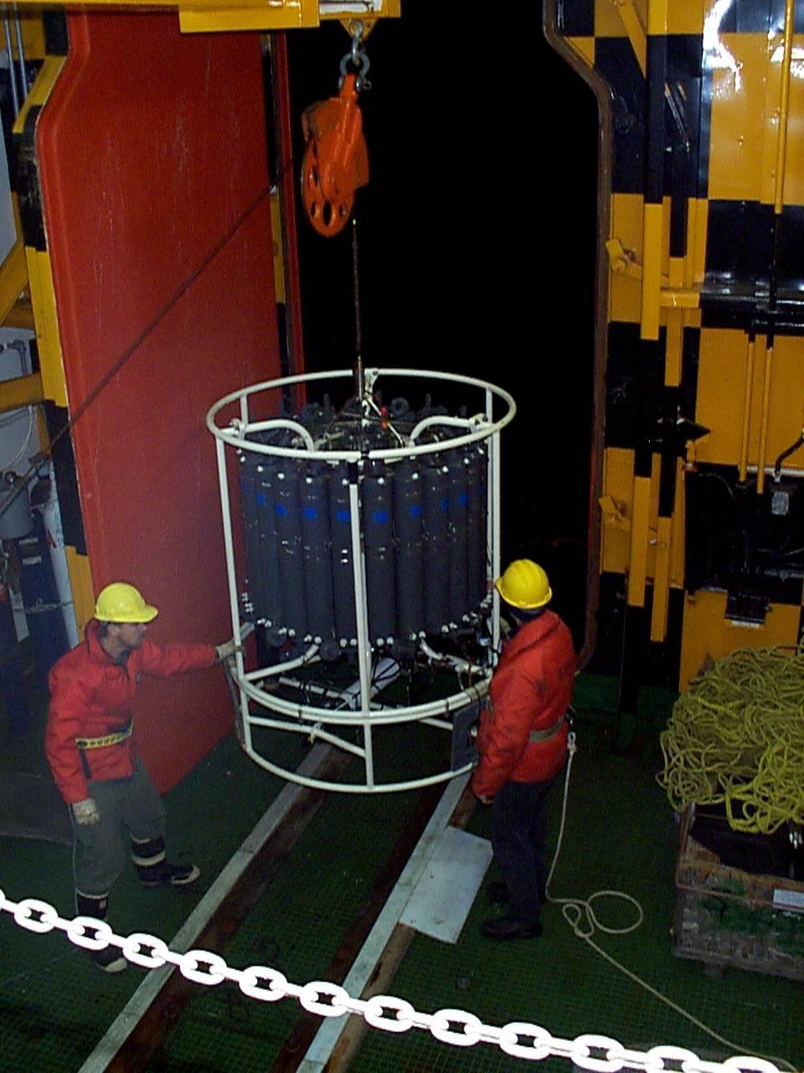
bringing in the CTD package
- Be sure to communicate with the winch operator what is happening with the CTD package:
- When you can see the package (usually around 20m from the surface), point at your eyes.
- When the CTD breaks the surface of the water, make a horizontal motion with your hand across your waist.
- It is very important to bring the package into the Baltic Room as quickly as safety will allow. If the water on the sensors freezes, it can damage them. If in a swell, the longer time in the surface water increases the chances of a strong wave snapping the cable.
- Once the CTD package is on board, pull in the bottom finder/shackle before the Baltic Room door shuts. While it is closing, secure the CTD package by attaching the rope on front (door side) and the strap on the rear (winch side).
- Notify the Bridge that the door is closed and the package is secure.
- To finish securing the package:
- Replace Pinger magnet.
- Hose off the package with fresh water to prevent salt build-up, especially the trigger mechanisms on the pylon (top-center of the rosette).
- Reconnect the temperature sensor tubes, and fill with distilled water.
- Use compressed air to blow out any water/ice from the pylon.
- Science groups should be encouraged to optimize sampling time between stations. Plan sampling order prior to the return of the package to the Baltic Room.

