Antarctic Circumpolar Current's Role in the Antarctic ice system: an overview

Douglas G. Martinson

Division of Ocean and Climate Physics,
Lamont-Doherty Earth Observatory
and
Department of Earth and Environmental Sciences Columbia University,
61 Route 9W, Palisades, NY 10964
dgm@ldeo.columbia.edu
1 845 365-8830
1 845 365-8736

Abstract
The Antarctic Circumpolar Current (ACC) provides fundamental control on the Antarctic ice system. The tilt of the isopycnals of the ACC, in response to strong westerlies, serves to thermally isolate the Antarctic continent from directly receiving the overwhelming subtropical ocean surface heat. This same tilt provides the northern boundary of the polar seas; as such it "contains" the statically stable cold fresh surface polar waters required for sea ice formation. In this manner it effectively sets the northern limit for seasonal sea ice formation. The isopycnal tilt also allows warm deep water to upwell to the surface near the continental margin in western Antarctica where the ACC skirts the continental shelf, leading to excessive ocean heat flux to the atmosphere in winter, and providing heat to melt the underside of the glacial ice.

Keywords: Antarctic Circumpolar Current, Ocean heat, Antarctica, glacial ice, sea level rise
1.0 Introduction
Currently the Antarctic Peninsula is undergoing extraordinary climate change. Investigation of the role of ocean heat in this change illuminates a number of fundamental insights regarding the important role of the Antarctic Circumpolar Current (ACC) in this and all other aspects of the Antarctic ice system. In addition to substantial physical changes (e.g., Earth's most extreme winter warming, and extensive sea ice and glacial ice loss), the western Antarctic Peninsula (WAP) marine ecosystem is changing from that of a continental polar environment to one of subpolar marine (Ducklow et al., 2007). The marine ecosystem is responding directly to changes in the ice cover and ocean physical conditions, themselves responding to climate forcing; this change is seen throughout the entire foodchain along the WAP (Montes-Hugo et al., 2009).
This paper describes the various roles played in this system by the ACC, using the extensive (18 years in 2010) gridded data set of the Palmer Long Term Ecological Research project (Pal LTER; Smith et al. 1995), supplemented by other available local data, including World Ocean Circulation Experiment (WOCE) lines. ACC interactions within the continental shelf region as revealed by LTER data along the WAP are used as a case study. WOCE lines help extend relevant insights around Antarctica. As such, the paper presents an overview of how the ACC influences the Antarctic cryosphere from existing studies.
2.0 Background
2.1 Dramatic WAP Climate Change
Dramatic climate change is being experienced in the present day WAP. Specifically: (1) Vaughan et al. (2003) show that this region is undergoing the fastest warming on Earth in winter (a time when the sun is near the horizon, contributing little radiative warming, and warm air cells are uncommon), (2) Cook et al. (2005) show that 87% of the marine glaciers in the WAP are in retreat, (3) Stammerjohn et al. (2008) show that all but a small area of the WAP perennial sea ice disappeared between 1979 and 1999, with the winter seasonal sea ice season shortened by 3-4 months (>40% reduction), this decline continued through the most recent years including 2010 (Stammerjohn et al., 2010, and pers. com. for year 2010), (4) Meredith and King (2005) show summer temperatures of the near-surface ocean rose more than 1 ˚C and salinities increased at the same time as the atmospheric warming, and (5) Ducklow et al., 2007 and W. Fraser (personal communication) show that the Adelie penguin colonies near Palmer Station in the WAP are going extinct since the Adelies cannot adapt to changes in winter ice coverage.
The only substantial source of heat in the WAP winter is the ocean. The warmest water, characterized by temperature (Tmax) and nutrient maxima, is Upper Circumpolar Deep Water (UCDW) at 3.5 - 4˚C above freezing in the ACC at the WAP. Martinson et al. (2008; hereafter MSISV08), using the first 12 years of Pal LTER data, show that on the WAP continental shelf, the heat content of the sub-surface water column (dominated by UCDW) has increased. During the 1990s increased upwelling of UCDW onto the shelf explains ~84% of this increase; ~21% is attributed to warmer UCDW.
While the WAP appears to be responding to global warming, the region also shows the largest surface response to ENSO events outside of the tropics (e.g., Yuan and Martinson, 2001 and Yuan, 2004), and has been well documented to respond to changes in the strength of the Southern Annular Mode (SAM). A positive bias in SAM leads to strengthening of the atmospheric polar jet, driving more and stronger polar lows into the WAP, forcing upwelling events (Marshall et al., 2004; Yuan, 2004). A similar response is realized from La Niña (Yuan, 2004). El Niño and negative SAM conditions each lead to the opposite (a reduction in storms and upwelling events).
2.2 Data
Most of the data for this study have been acquired in the Pal LTER marine sampling grid shown in Figure 1. The LTER project has collected shipboard data since 1991, including each January since 1993 (i.e., summer snapshots). This has been recently supplemented by the deployment of 5 Lamont temperature-string moorings on the WAP continental shelf (mooring strings contain temperature and pressure sensors at fixed locations from just above the seafloor to a depth near 75 m depth, assuring sampling of all sub-surface water), and austral summer launches of SLOCUM ocean gliders (1 in austral summer 2007; 2 in 2008; we now have a pool of 3 such gliders in the project operated by Oscar Schofield of Rutgers). It is clear from the research articles appearing in the 2008 Deep Sea Research Part II special issue "Palmer, Antarctica Long Term Ecological Research", that the delivery of warm deep water to the continental shelf of the WAP by the ACC plays a critical role in the physical and ecological system. Hence data from this site are useful for revealing that aspect of the ACC's role in the Antarctic ice system.

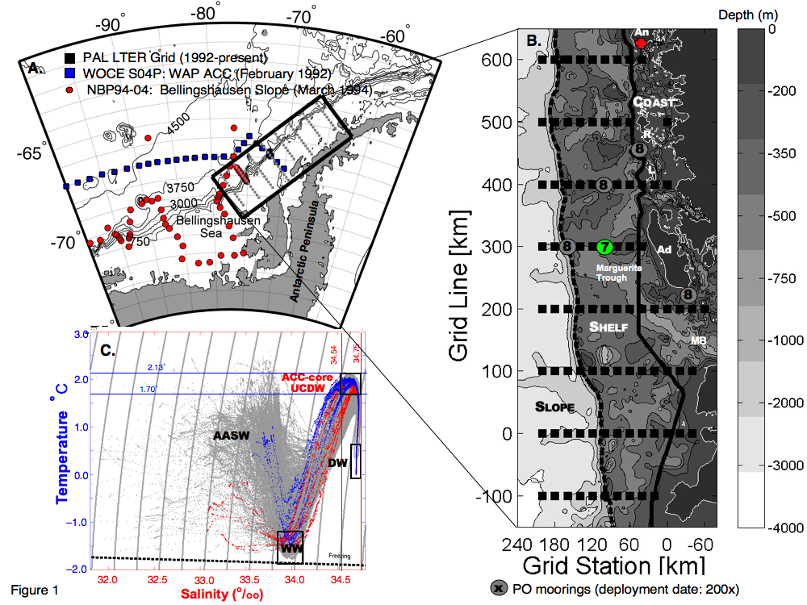
Figure 1: A. Regional map showing location of Pal LTER nominal ocean grid from which data for this study have been acquired. B. Ocean grid shows standard sample locations (solid squares) and geographic features labeled (top-to-bottom): An = Anvers Island (home of Palmer Station indicated by red cross), R = Renaud Island, L = Lavosier Island, Ad = Adelaide Island and MB = Marguerite Bay. 300.100 mooring, discussed in text, is green dot in grid center (number in center of mooring circles indicates year mooring was deployed). C. Temperature-Salinity plot shows collection of all summer profiles collected in grid since start of LTER project, identifying primary water masses, including UCDW supplying the ocean heat to the grid.
2.3 Physical Setting
The grid overlays the broad continental shelf of the WAP which is ~450 meters in depth (excluding canyons), running ~200 km in cross-shelf width and ~400 km along the WAP (the grid has been recently extended another ~300 km to the southwest). The southern boundary of the ACC, is most easily defined by the southern-most presence of UCDW (Orsi et al., 1995), given that the Southern ACC front is not always present. The southern boundary migrates to the continental slope once it passes the Ross gyre and stays there throughout the entire SE Pacific region (Orsi et al., 1995; MSISV08) along the continental rim of the Amundsen-Bellingshausen Seas, riding up to the shelf-slope break in the WAP. This makes warm UCDW directly available to the WAP shelf and the Amundsen Sea Embayment (where the major ice streams draining the massive West Antarctic Ice Sheet, WAIS, enter the sea), allowing for easy ventilation to the atmosphere and glacial melt. In this important respect, the West Antarctic continental shelf is unique in Antarctica for this proximity of the ACC and delivery of warm UCDW (Figure 2).
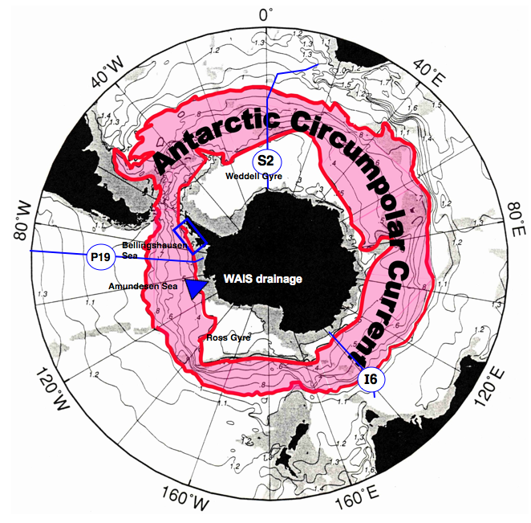
Figure 2: Polar projection shows proximity of Antarctic Circumpolar Current to entire Antarctic continent. ACC transports warm UCDW. Amundsen-Bellingshausen Seas are unique in entire Antarctic since here the ACC southern boundary follows the continental slope (up to shelf-slope break in WAP), delivering the warm UCDW directly to the shelf for ventilation of heat to the atmosphere and for access to the underside of glacial ice. Blue arrow head shows location of Amundsen Sea Embayment where major ice streams draining the WAIS flow into the sea. ACC is defined by those limiting geopotential surfaces that pass through Drake Passage (ACC based on climatological dynamic topography of Orsi et al., 1995); blue box shows location of LTER sampling grid. Blue-colored, labeled (with WOCE cruise track) lines cutting across ACC in 3 locations are WOCE diagrams identifying location of sections in Figure 3.
3.0 Role of the ACC
3.1 Thermal Isolation
First and foremost in the Antarctic thermal balance is the fact that the ocean water contains >4000 times more thermal energy than air of the same volume (V) and temperature above freezing (ΔT), reflecting the fact that thermal energy is a function of density and specific heat capacity. And, given that strong solar forcing is absent half of the year, the ocean is the dominant source of heat in winter. Thus, the presence of warm water near the Antarctic continent can greatly moderate the atmospheric temperature and melt ice of any kind.
The most obvious role of the ACC is the fact that it thermally isolates Antarctica, as suggested by Kennett (1977), by keeping warm subtropical surface waters from approaching the continent. In particular, the lack of physical boundaries along its path prevents development of zonal pressure gradients driving meridional flow. Also, the westerlies force the ACC so that the stratified water column is tilted higher in the south. Together, these prevent the warm subtropical surface waters north of the ACC from directly moving south across the northern edge of the ACC, as seen in the WOCE temperature sections of Figure 3. Each section from the SE Pacific (P16), mid-Atlantic (S2) and Indian Ocean (I6), clearly shows that the tilt prevents the warm subtropical surface waters, containing an immense heat content, from moving south directly to Antarctica, helping to keep it and its surrounding oceans cold (establishing Kennett’s “steep surface water temperature gradient between polar and tropical regions”). Note that this is not the case in the North Atlantic where warm subtropical waters (in the North Atlantic Drift) are transported directly to the Nordic Seas impeding sea ice extension to the south (Untersteiner, 1988) near Fram Strait.
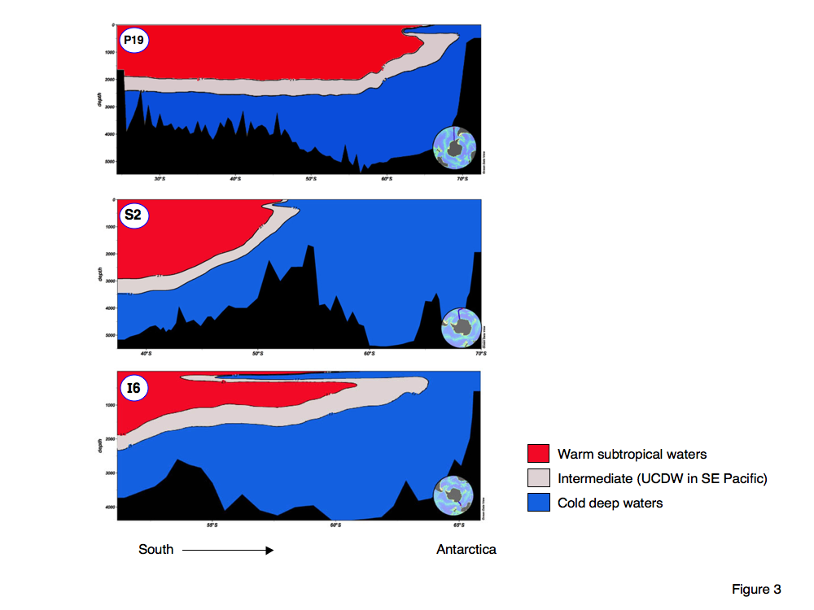
Figure 3: 3-color WOCE Temperature sections along the tracks crossing the ACC in polar projection (in Figure 2) labeled same as those sections. Sections show that tilt of the isopycnals associated with ACC prevent warm tropical waters (red) from reaching Antarctic continental margin. Warm UCDW layer (white) slips along the tilted isopycnals to reach the continental slope in section P19 along the WAP, and elsewhere only reaches the northern limit of the polar waters.
While the ACC delimits the southern boundary of subtropical surface waters, it also "contains" the cold fresh surface polar waters required for sea ice formation, so it effectively sets the northern limit for seasonal sea ice formation. That limit defines the extent of the Antarctic polar oceans (as seen in the spatial distribution of Winter Water, generated by the deep winter mixed layers resulting from destabilizing brine rejection associated with sea ice growth, Toole, 1981). In some regions the weak stratification of the Southern Ocean water column leads to a strong bathymetric control on the location of the ACC. Paleoceanographic studies indicating a northward migration of the sea ice fields during ice age climates (e.g., CLIMAP reconstruction, 1981 and Gersonde et al., 2005) are also revealing a northward migration of the ACC. In those regions showing strong bathymetric control on the ACC, this northward migration implies changes releasing the ACC from the bathymetric control.
3.2 Modern heating of WAP waters over the shelf
While the ACC inhibits warm subtropical surface waters from southward extension into the polar oceans, the warm deep water (as UCDW in the ACC) is elevated from depth along the tilted isopycnal surfaces. In the WAP, the warm deep water is elevated to the depth of the floor of the continental shelf (section P19 in Figure 2) allowing some of this warm water direct access to glacier margins. In the other ocean basins the warm water enters the polar gyres, providing the heat that dominates the ocean stability and limits the thickness of the seasonal sea ice (Martinson, 1990, Martinson and Iannuzzi, 1998, 2003).
MSISV08 document the ocean heat content on the shelf, and show that when including historical data in the same vicinity of the LTER sampling grid there has been an exponential increase in this heat content over the decades since the 1960s. Fundamental to this increased ocean heat content is the applicability of the WAP findings to the Amundsen Sea Embayment. Recent research there indicates that indeed it is the (same) warmed UCDW water in that region responsible for the accelerated glacial melt there (e.g., Shepherd et al., 2002, Payne et al., 2004). This, as well as the robustness of the temporal increase in ocean heat is the focus of current research and will be presented in a separate publication.
4.0 Discussion and Conclusions
4.1 Discussion.
The ACC is playing a crucial role in the Antarctic ice system. It serves to minimize the flux of surface subtropical heat into the polar oceans, thus thermally isolating the Antarctic continent. For that same reason, it also serves as a northern boundary to the polar seas, containing the fresh cold stable surface waters necessary for sea ice formation and limiting the northern extent of the seasonal sea ice fields. Some of the modern ACC path is controlled by bathymetry; paleoceanographic data indicating north-south shifts in the sea ice fields suggest a release from that bathymetric control — presumably something that could be achieved if, for example, enough sea ice melted at the northern edge of the polar gyres, forming a strongly stratified surface layer, limiting penetration of surface forcing and consequently decreasing the bathymetric control.
The ACC transports warm water (relative to freezing), in the form of UCDW, around the continent. The edge of the East Antarctic ice cap is buffered from this heat by large polar gyres (the Weddell and Ross gyres) and by a seafloor bathymetry that steers it through the Indian Ocean minimizing its contact with the continental shelf in that region. Only after it passes the Ross Sea gyre does it immediately move continent-wise likely owing to the wavenumber 3 atmospheric circulation pattern (van Loon and Jenne, 1972), where it continues its journey skirting the edge of the continental shelf making the heat easily accessible to the region most susceptible to draining the WAIS and WAP glaciers. In the WAP it is at a depth where a simple offshore surface flow (MSISV08) will draw the warmest water onto the shelf.
4.2 Conclusions.
It is shown that the tilt of the isopycnals of the ACC contributes to the thermal isolation of Antarctica, and in a complementary sense, serves to isolate the seasonal sea ice fields. That same tilt delivers warm deep water to the continental shelves of the western Antarctica providing heat to a region sensitive to glacial melt. Still at question is the degree to which the warm deep water directly contributes to the accelerated glacial melt currently being experienced by the WAIS via the ice streams (Pine Island, Thwaites and Smith) flowing into the Amundsen Sea Embayment.
Acknowledgments
Thanks to the organizers of the ACE Symposium for asking me to participate in that interesting forum, and providing helpful comments for this paper. And, thanks, as always to Richard A. Iannuzzi who contributed heavily to the analyses and figures, and provided insightful science and editorial suggestions. Deepa Manandhar contributed to the figures and references. Thanks to the crew, staff and Raytheon Polar Services and our own LTER science support teams on our numerous LTER cruises aboard the RVIB LM Gould; all cooperated fully to help us acquire the data needed to answer the questions we were addressing. This work was supported by NSF grants: LTER 0217282 and 0823101, and SASSI. NOAA grant: NA08OAR4320912. This paper is LTER contribution xxx and Lamont contribution xxx.

References
AchutaRao, K.M., Ishii, M., Santer, B.D., Gleckler, P.J., Taylor, K.E., Barnett, T.P., Pierce, D.W. Stouffer, R.J., Wigley, T.M.L., 2007. Simulated and observed variability in ocean temperature and heat content. Proceedings of the National Academy of Sciences 104 (26), 10768-73.
Alley, R.B., Clark, P.U., Huybrechts, P., Joughin, I., 2005. Ice-sheet and sea-level changes. Science 310, 456-460.
Anderson, J.B., 2002. Antarctic Marine Geology, Cambridge University Press, Cambridge, UK.
Barnett, T.P., Pierce, D.W., Shnur, R., 2001. Detection of anthropogenic climate change in the world's oceans. Science 292, 270-274.
Barnett, T.P., Pierce, D.W., AchutaRao, K.M., Gleckler, P.J., Santer, B.D., Gregory J.M., Washington, W.M. 2005. Penetration of human –induced warming into the world’s oceans. Science 309, 284-287.
Böning, C.W., Dispert, A., Visbeck, M., Rintoul S.R., Schwartzkopf, F.U., 2008. The response of the Antarctic Circumpolar Current to recent climate change. Nature Geoscience 1, 864-869.
Cook, A.J., Fox, A.J., Vaughan, D.G., Ferrigno, J.C., 2005. Retreating glacial fronts on the Antarctic Peninsula over the past half-century. Science 308, 541-544.
Ducklow, H.W., Baker, K.S., Martinson, D.G., Quetin, L.B., Ross, R.M., Smith, R.C., Stammerjohn, S.E., Vernet, M., Fraser, W., 2007. Marine pelagic ecosystems: The West Antarctic Peninsula. Philosophical Transactions of the Royal Society of London Special Theme Issue, Antarctic ecology: From genes to ecosystems 362, 67-94.
Gersonde, R., Crosta, X., Abelmann, A., Armand, L., 2005. Sea-surface temperature and sea ice distribution of the Southern Ocean at the EPILOG Last Glacial Maximum a circum-Antarctic view based on siliceous microfossil records, Quaternary science reviews, 24, 869-896. doi:10.1016/j.quascirev.2004.07.015
Gille, S.T., 2002. Warming of the Southern Ocean since the 1950s. Science 295, 1275-1277.
Gille, S.T., 2008. Decadal-scale temperature trends in the southern hemisphere ocean. Journal of Climate 21, doi: 10.1175/2008JCLI2131.1.
Jacobs , S.S., Hellmer, H.H. and Jenkins, A., 1996. Antarctic ice sheet melting in the southeast Pacific. Geophysical Research Letters 23 (9), 957-960.
Kennett, J.P., 1977. Cenozoic evolution of Antarctic glaciation, the circum-Antarctic ocean, and their impact on global paleoceanography. Journal of Geophysical Research 82 (27), 3843-3860.
Levitus, S., Antonov, J., Boyer T.P., Stephens, C., 2000. Warming of the world ocean. Science 287, 2225-2229.
Levitus, S., Antonov, J.I., Wang, J., Delworth, T.L., Dixon, K.W., Broccoli, A.J., 2001. Anthropogenic warming of earth's climate system. Science 292, 267-270.
Levitus, S., Antonov, J.I., Boyer, T.P., 2005. Warming of the world ocean, 1955-2003. Geophysical Research Letters 32, doi: 10.1029/2004GL021592.
Marshall G.J, Stott P.A., Turner J., Connolley W.M., King J.C., Lachlan-Cope T.A., 2004. Causes of exceptional atmospheric circulation changes in the southern hemisphere. Geophysical Research Letters 31, L14205, doi:101029/2004GL019952.
Martinson, D.G., 1990. Evolution of the Southern Ocean winter mixed layer and sea ice: open ocean deepwater formation and ventilation. Journal of Geophysical Research 95, 11641-11654.
Martinson, D.G., Iannuzzi, R.A., 1998. Antarctic ocean-ice interaction: Implications from ocean bulk property distributions in the Weddell Gyre, in: Jeffries, M. [Ed.], Antarctic Sea Ice: Physical Processes, Interactions and Variability. Antarctic Res. Series, vol. 74, American Geophysical Union, Boston, pp. 243-71.
Martinson, D.G., Iannuzzi, R.A., 2003. Spatial/temporal patterns in Weddell Gyre characteristics and their relationship to global climate. Journal of Geophysical Research 108 (C4) doi:10.1029/2005GL024042.
Martinson, D.G., Stammerjohn, S.E., Iannuzzi, R.A., Smith R.C., Vernet, M., 2008. Western Antarctic Peninsula physical oceanography and spatio-temporal variability. Deep-Sea Research II 55, 1964-1987
Meredith, M.P., King, J.C., 2005. Rapid climate change in the ocean to the west of the Antarctic Peninsula during the second half of the twentieth century, Geophysical Research Letters, 32, L19604. doi:10.1029/2005GL024042.
Moffat, C., Owens, B., Beardsley, R.C., 2009. On the characteristics of circumpolar deep water intrusions to the west Antarctic Peninsula continental shelf. Journal of Geophysical Research, 114, C05017, doi:10.1029/2008JC004955.
Montes-Hugo, M.A., Doney, S.C., Ducklow, H.W., Fraser, W., Martinson, D., Stammerjohn, S.E., Schofield, O., 2009. Recent changes in phytoplankton communities associated with rapid regional climate change along the Western Antarctic Peninsula. Science 323, 1470-1473.
Orsi, A.H., Whitworth, T., Nowlin, W.D., 1995. On the meridional extent and fronts of the Antarctic Circumpolar Current. Deep Sea Research I, 42 (5), 641-673.
Payne, A.J., Vieli, A., Shepherd, A.P., Wingham, D.J., Rignot, E., 2004. Recent dramatic thinning of largest West Antarctic ice stream triggered by oceans. Geophysical Research Letters 31, L23401, doi:10.1029/2004GL021284.
Schlitzer, R., 2009. Ocean Data View, http://odv.awi.de.
Shepherd, A., Wingham, D. and Mansley, J., 2002. Inland thinning of the Amundsen Sea sector, west Antarctica, Geophysical Research Letters 29(10), 2-1.
Smith, R.C., Baker, K.S., Fraser, W.R., Hofmann, E.E., Karl, D.M., Klinck, J.M., Quetin, L.B., Prezelin, B.B., Ross, R.M., Trivelpiece, W.Z., Vernet, M., 1995. The Palmer LTER: A long-term ecological research program at Palmer Station, Antarctica. Oceanography 8 (3), 77-86.
Stammerjohn, S.E., Martinson, D.G., Smith, R.C., Iannuzzi, R.A., 2008. Sea ice in the western Antarctic Peninsula region: Spatio-temporal variability from ecological and climate change perspectives. Deep Sea Research Part II, 55 (18-19), 2041-2058, doi:10.1016/j.dsr2.2008.04.026.
Steig, E.J., Schneider, D.P., Rutherford, S.D., Mann, M.E., Comiso, J.C., Shindell, D.T., 2009. Warming of the Antarctic ice-sheet surface since the 1957 International Geophysical Year. Nature 457 (22), doi:10.1038 /nature 7669.
Thoma, M., Jenkins, A., Holland, D., Jacobs, S., 2008. Modelling Circumpolar Deep Water intrusions on the Amundsen Sea continental shelf, Antarctica. Geophysical Research Letters, 35, L18602, doi:10.1029/2008GL034939.
Toole, J.M., 1981. Sea ice, winter convection, and the temperature minimum layer in the Southern Ocean, Journal of Geophysical Research, 86, 8037-1047.
Untersteiner, N., 1988. On the ice and heat balance in Fram Strait. Journal of Geophysical Research 93 (C1), 527-531.
van Loon, H., Jenne, R.L., 1972. The zonal harmonic standing waves in the southern hemisphere. Journal of Geophysical Research 77 (6), 992-1003.
Vaughan, D.G., Marshall, G.J., Connolley, W.M., Parkinson, C., Mulvaney, R., Hodgson, D.A., King, J.C., Pudsey, C.J., Turner, J., 2003. Recent rapid regional climate warming on the Antarctic Peninsula. Climatic Change 60, 243-274.
Yuan, X., Martinson, D.G., 2001. The Antarctic Dipole and its predictability. Geophysical Research Letters 28 (18), 3609-3612.
Yuan, X., 2004. ENSO-related impacts on Antarctic sea ice: a synthesis of phenomenon and mechanisms. Antarctic Science 16 (4), 415-425.

A rather formal nomenclature exists whereby "climate change" refers to anthropogenic change, and "climate variability" refers to natural climate variability. In this document, I am not adhering to that nomenclature — climate change simply implies that the climate is changing, independent of attribution.
For a detailed popular description of this, see: Montaigne, F., 2010. "Fraser's Penguins", Henry Holt Press, 288 pp.
Upwelling (84%) and warming (21%) of Tmax are independent, hence the total exceeds 100%.
Moorings designed by Lamont oceanographer Bruce Huber, designed to provide a temperature profile through the water column using fixed-depth sensors.
The ACC does briefly encounter the continental slope in short segments in the Indian Ocean sector, but it is not clear that that results in any significant delivery of UCDW to the continental shelf in those locations and if so, what the consequence is.

