 |   The Network Newsletter Vol. 14 No.1 Spring 2001

LTER Home Page  Previous Issues | Field Trip to Zones Ateliers-France  Karen Baker, Palmer LTER  The ILTER workshop at Snowbird in August 2000 resulted in a meeting between US LTER and French Zones Ateliers (ZA) participants mid January 2001 in Versailles, near Paris. ZAs are part of the French Centre National dela Recherche Scientifique (CNRS, http://www.cnrs.org). These meetings explored the existing and potential developments for ecological networks and collaborations. An afternoon trip to  Forest Fontainebleau and Station Biologique de Foljuif provided an opportunity for participants to explore the research sites. Forest Fontainebleau, a Man and the Biosphere (MAB) reserve since December 1998, is one of the few very old lowland forests in Europe. It is located south of Paris, west of the Seine. The forest was last logged in 1372 and possibly not since. The area has 20 to 30 year storm events with winds up to 140 km/hr. The most recent of these occurred in December 1999. The forest is dominated by beech trees with 5-15% in gap regeneration at any one time. Plantings have included braken fern, oak and scots pine and, gap dynamics have lead to low diversity.  The Station Biologique de Foljuif is associated with Ecole Normale Superiore. It was created decades ago as a field station for forest studies,use now includes experimental ecology, such as biodiversity, population dynamics, landscape fragmentation, and breeding termites. The station includes 50 hectares of land although additional land is being acquired in order to focus more on long-term experiments. New work includes an interest in mesocosm manipulations and linking experimental ecology and field observations from different landscapes. Since human activities impact carbon storage in forests and in rural environments, the Forest Fontainblau and the Station Biologique de Foljuif are sites from which community structure and ecosystem function can be considered.
  Inside this Issue:
  SITE X SITE
  A review of cross-site activities resulting from the LTER All-scientiests Meeting
  Niwot Publishes Third Volume in LTER/OUP Synthesis Series
  Prarie Dogs Run the Show at Shortgrass Steppe LTER
  Research Activities at Central Arizona-Phoenix LTER
  NETWORKING
  Eleven-site ANPP Study Demonstrates Value of Network Science
  List of Cross-site Research and Synthesis Post-ASM 2000
  Summary of the Schoolyard LTER Working Group Plans and Projects
  International Network-to-Network Collaboration Summary of the Science Policy Forum
  Field Trip to Zones Ateliers France
  Summary of the Information Management Workshop, Hungary
  CALENDAR
  Coming Events
  Receive a copy
  Download the Newsletter as a .PDF
  (Requires Adobe Acrobat Reader)
  The Network News is produced each spring and fall at the LTER Network Office through a cooperative agreement between The National Science Foundation and The University of New Mexico
  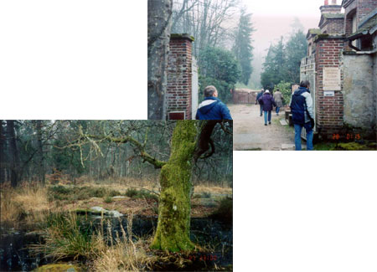
  On a field trip to Forest Fontainebleau (left) and Station Biologique de Foljuif (above), at the French Zones Ateliers, diring the recent Science Policy Forum, Versailles, France. Photos: Karen Baker
Home | For LTER Community | ILTER |
Copyright © 2001 Long Term Ecological Research Please contact Patricia Sprott with questions or comments about this website. For technical assistance, please contact webmaster@lternet.edu

