LTER Network Newsletter Article- Fall 2001

Palmer LTER Outreach Networks
By Karen S. Baker, Palmer LTER Information Manager and Education Outreach Coordinator

A marine science technician, an Eagle Scout and an adult basic skills teacher have in common plans this season to participate in Antarctic science research efforts and to share their experiences through field journals. This diverse group of individuals is united by the common quest to participate in Antarctic and long-term research, to explore ecosystem and partnership science, as well as understand and use technology to facilitate the integration of information across language, community and datasets. The Palmer Station Long-Term Ecological Research (LTER) site through its schoolyard education outreach program (http://pal.lternet.edu/education) bridges these participants and their respective networks: the public schools, the Boys Scouts of America (BSA) and the Teachers Experiencing the Artic and Antarctic (TEA) Program.

Marine Science Technician Participates in LTER Ice Cruise

Richard Iannuzzi, a marine science technician and computer programmer with experience in physical oceanographic data collection and analysis, is participating in an ongoing Palmer LTER winter ice cruise West of the Antarctic Peninsula. The cruise focuses on sea ice because of its importance in the dynamics of the Antarctic ecosystem.

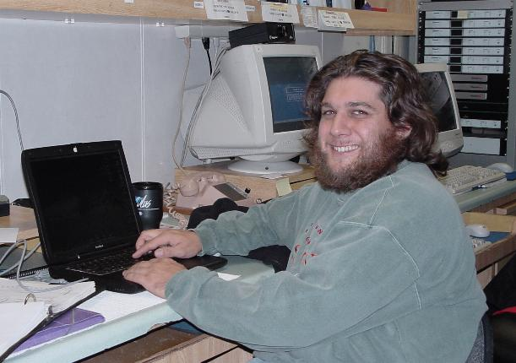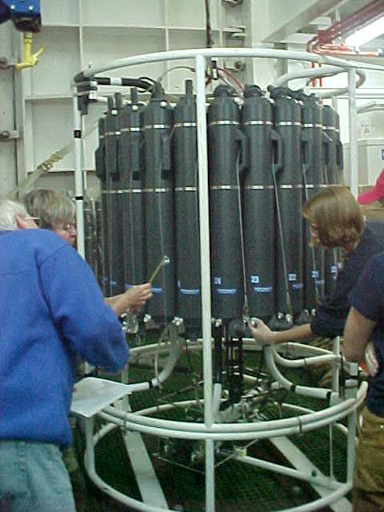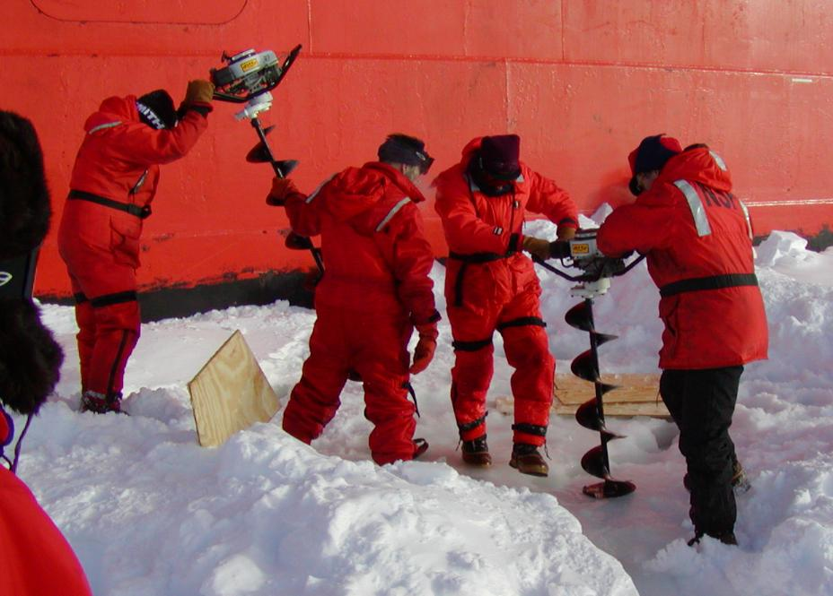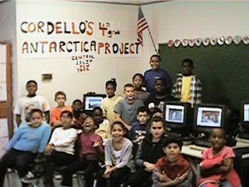

Antarctic Ship Workstation CTD Instrument Ice Drilling New York Cordello Class

Rich says "I especially enjoy photography while I'm sailing on a cruise, but that is as much due to the environment as it is my own interests. The beauty of the Antarctic drives me to try to capture it on film, although I like photography anywhere, anytime. Fishing is a favorite pastime of mine and it's connection to the ocean is no coincidence. I love being with the sea."

His journal is sent home daily from the ship via satellite. The project developed from his outreach experiences on a previous cruise as well as from discussions with his father. His father, a fourth grade teacher, is coordinating journal communications with four New York elementary school classrooms as well as sharing the Antarctic connection in a variety of additional school forums.

Scout Prepares for Antarctic Deployment

Tim Brox, a recent graduate of Clovis West High School (Fresno, CA) and an Eagle Scout, was selected in April by BSA to participate in an NSF Office of Polar Programs sponsored program. The precedence for this program which now sends a Boy Scout and Girl Scout to the Antarctic in alternate years, can be traced to Eagle Scout Paul Siple who joined an expedition in 1928 at the request of Admiral Byrd. Tim's selection is particularly appropriate given his interest in science and the marine environment:

"One aspect of science that always captivated me was marine science. I don't know if it's the natural beauty of the oceans or the sense of adventure that they instill, but whatever the reason I focused my interest in science towards the seas."

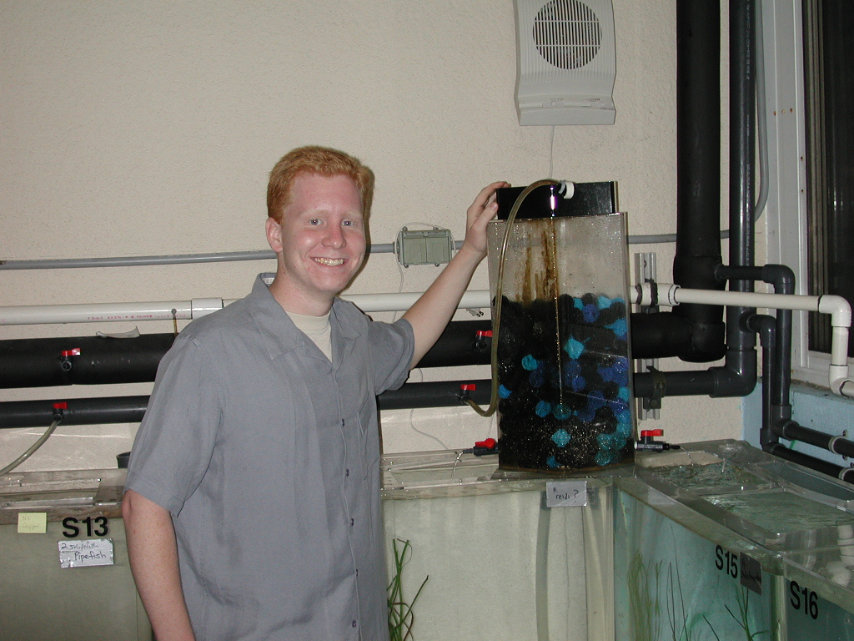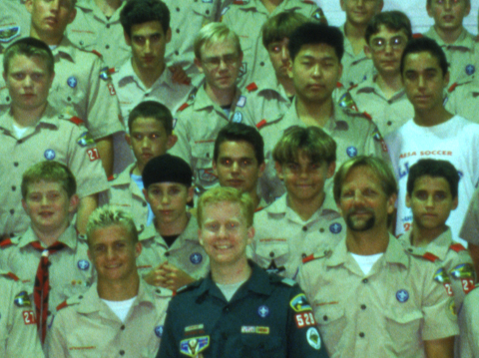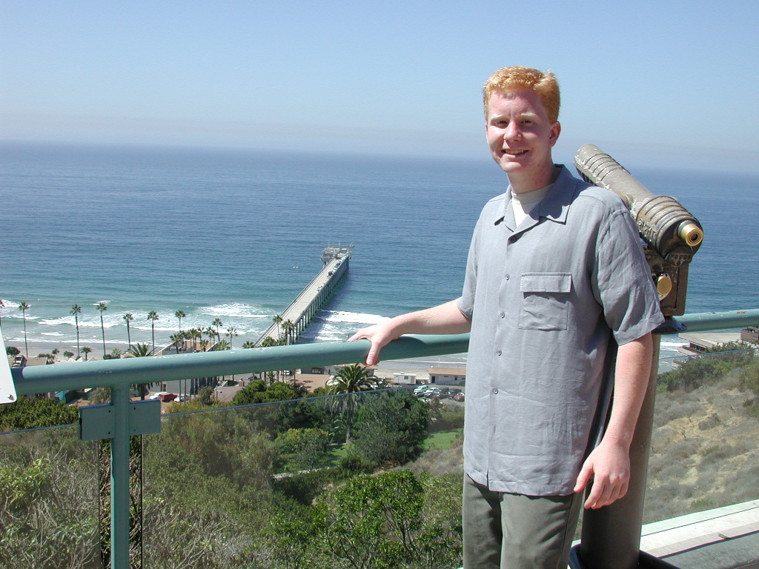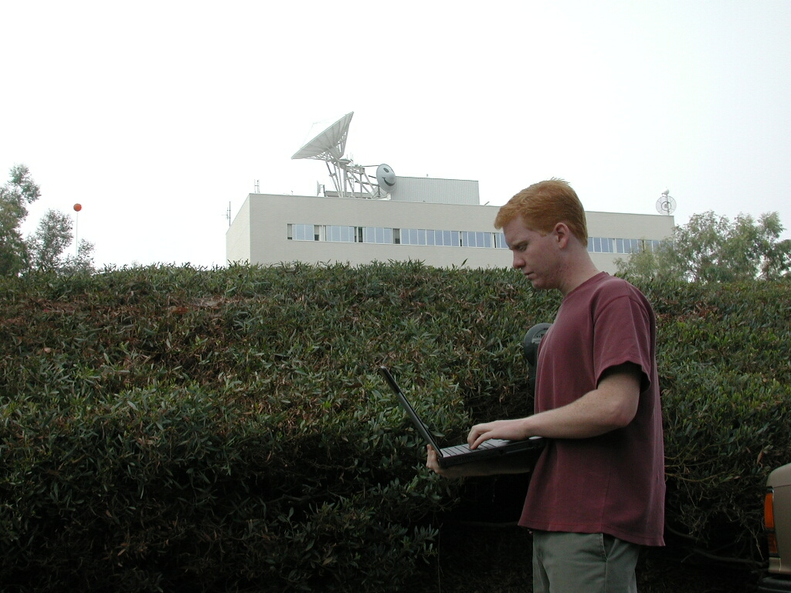

Birch Aquarium San Diego Scout Meeting UCSD-SIO pier SD Supercomputer Center

His two year research project on bioremediation and oil spill clean up incorporated a home aquarium technique of using bio balls as a growth substrate for water cleaning bacteria. Tim developed a growth surface to promote bacteria and fungi growth that had some impact on clean up of oil spills. His research culminated in 2001 when his project received third place in Environmental Science in the Intel International Science and Engineering Fair.

Tim will have the opportunity to visit research scientists in their home institutions as well as in the field. Having taken a year prior to entering college to both learn about and participate in scientific research, he will visit the three US Antarctic research stations (Palmer Station, South Pole and McMurdo Station) in addition to a variety of field camps. Projects that he will interface with while in the US include the two Antarctic LTER (Palmer Station and the McMurdo Dry Valleys) as well the marine Santa Barbara Channel LTER. As an introduction to Antarctic research and marine as well as information management and technology, Tim traveled to San Diego in September to begin his training. Hosted by Palmer LTER information manager and outreach coordinator Karen Baker, he was able to meet with researchers at Scripps Institution of Oceanography, the Stephen Birch Aquarium and the San Diego Supercomputer Center. Tim will deploy mid October via New Zealand to McMurdo Station and South Pole aboard a LC130 Hercules cargo plane and in February through Chile to Palmer station aboard the Research Vessel Laurence M. Gould.

Teacher deploys for Antarctic Summer

Susan Cowles, a teacher of adult basic skills development and high school completion classes at Linn-Benton Community College, Corvallis Oregon, was selected by the NSF/OPP TEA Program (http://rice.tea.edu) to visit the Antarctic early next year. In preparation for her trip, she visited the laboratory of Dr. Hugh Ducklow, a Palmer LTER Principle Investigator at the College of William and Mary College, Virginia Institute of Marine Sciences, this summer. Susan will conduct research alongside Dr. Ducklow and his team on the subject of microbial biology and persistent organic pollutants.

Susan relates: "Through the years, I've found that science is an excellent and enjoyable context for teaching, learning and practicing the basic skills of critical reading, writing, and mathematical problem solving. And, polar science is particularly exotic and fascinating!"

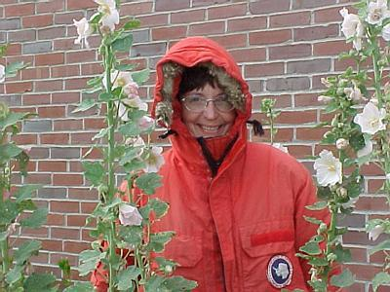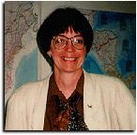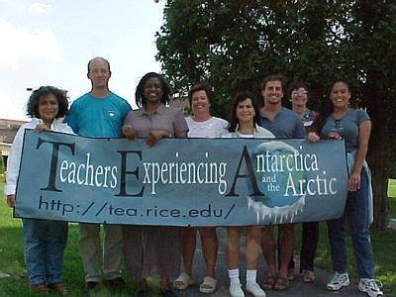

Preparing for Antarctic Conditions In the Classroom TEA Orientation

Participating in math instructional reform and the use of technology in adult literacy programs, her work incorporates use of the Internet as a teaching and learning tool; she now maintains an online special collection in science and numeracy resources for the National Institute of Literacy (http://literacynet.org/sciencelincs). Susan will work at
Palmer Station beginning in January-February 2002 focusing with Dr. Ducklow and his team on the role of air-borne organic pollutants in Antarctic coastal seas.

Antarctic Electronic Journals

The Antarctic ecosystem undergoes extremely large seasonal changes in both light and sea ice. While the Palmer LTER team has been working to understand the impacts of sea ice change on the Antarctic marine ecosystem since 1991, this season Rich, Tim and Susan will observe for themselves just how this unique ecosystem is dominated by the advance and retreat of sea ice. They will participate with researchers documenting and investigating the Antarctic ecosystem and its change over time. Through online journaling (http://pal.lternet.edu/field/0102season), they will share their insights and adventures with students, Scouts, teachers and the public.

